Modern Techniques in Well Design

Dennis E. Williams, Ph.D.

DENNIS E. WILLIAMS, a native of California, received his advanced degrees in hydrology and ground-water hydrology at the New Mexico Institute of Mining and Technology, where he studied under M.S. Hantush and C.E. Jacob. Following graduation he planned and directed geologic and hydrologic studies in the Owens and Mono basins with regard to the amount of surface and ground-water resources available to the city of Los Angeles. From 1971 to 1975 Dr. Williams was involved in the planning and execution of a number of ground-water projects in Iran. Form 1976 to 1978 he was a consultant to the government of Iran as special advisor to the Ministry of Energy. He is also a consultant to the United Nations (UNPD). Dr. Williams currently serves as president of Geoscience Support Services, a company specializing in advanced technology consulting as applied to engineering and earth sciences.

Modern Techniques in Well Design

Dennis E. Williams

A direct benefit of efficient wells is reduced pumping costs. Well efficiency is controlled by several factors, including aquifer, drilling damage, and turbulent-flow losses at or near the well screen. Screen entrance velocity is not a critical design factor if values are less than 2-4 fps (0.6-1.2 m/s). For most wells, the required open areas of a screen need only be 3-5 percent. A new method of designing minimum length of well screen based on laminar flow-turbulent flow considerations is presented, along with a simple field test to calculate the efficiency of an existing well or to provide a criterion for termination of development of a newly constructed well.
Efficient well construction depends on a comprehensive understanding of the factors that influence the hydraulics of groundwater flow to wells. Considerable field and experimental study has been devoted to the subject. Many investigators have proposed solutions for the flow of groundwater to wells. These solutions, for the most part, have been confirmed to be sufficiently accurate to allow engineers to properly design and manage groundwater resources. In some cases, however, design parameters not fully understood were oversimplified or grossly approximated-- resulting in inefficient wells.
This project simulated field conditions of groundwater flowing from aquifer sands through the filter zone and into the well screen. This was done with a large sand tank model capable of producing radial flow in a one-sixth section of a well and aquifer. Commercially available 10-in. (250 mm) well screens were used, and a system of reservoirs and pumps allowed flows up to 300 gpm (19 L/s). A constant-head reservoir connected to a chamber along the back of the model provided a line drive, allowing up to 60 ft (18 m) of available drawdown at the well (Figure 1).
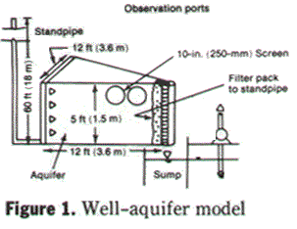
Measurement of pressure head and flow throughout the model was achieved with an array of 47 small piezometer tubes. These piezometers were connected to a sensitive transducer,* and values were obtained with a microcomputer. Particles of sand in the well discharge ranging from 20 to 1000 mm in diameter were counted with a particle counter. †
Two aquifer materials were used in these experiments. Six commercially available screens were selected for the tests with open areas ranging from <1 to 36 percent. Well efficiencies were calculated for the six screens based on differences in water levels inside and outside the screen. Testing procedures involved varying the discharge rates and measuring water levels in the aquifer, filter zone, and well.

* SCANIVALVE, San Diego, Calif.
† Model PC320, HIAC/ Royco Instrument Div., Menlo Park, Calif.

Entrance velocities and sand content were measured for each of the tests. A complete description is given elsewhere.¹ Much of the information presented in this article is based on results obtained from five years of testing and analysis using this model. Emphasis is placed on those aspects of well design that pertain to wasteful losses of energy and the methods used to control or minimize such losses.

Well Design
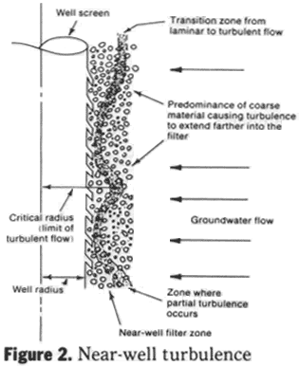
Critical Radius. Turbulence occurs in the near zone of the well filter when inertial forces predominate over viscous forces. The transition between completely laminar and completely turbulent is evidenced by the gradual scatter of turbulence throughout all pores of the medium. Thus, the first deviations from Darcy's law sorrespond to the beginning of appreciable eddy losses in the larger pores. These localized regions of turbulence spread to the smaller pores as velocity increases (Figure 2).
The following equations are based on Darcy's law and the Darcy - Weisbach formula, and apply equally to uniform aquifers, filter packs (as used in the model), and field conditions. Darcy's law shows that for laminar flow, the hydraulic gradient dh/dr over a column of sand with a characteristic grain diameter d, kinematic viscosity v, Reynolds number R, and intrinsic permeability k may be expressed as:
dh/dr = a₂v²R/gkd (1)
Similarly, for turbulent flow the head loss is proportional to the square of the velocity (Darcy- Weisbach formula) or in terms of Reynolds number:
dh/dr = a₂v²R²/gkd (2)
In which R = Reynolds number = vd/ v; v = velocity; k = intrinsic permeability; d = characteristic grain diameter (assumed = 50 percent passing size); v = kinematic viscosity of water (1.233 × 10⁻⁵ sq. ft/s); a₁ , a²; = constants (a₁ = 1 for laminar flow, a² = 1/R ); and g = gravitational constant (32.2 fps² [9.8 m/s²; ]).
The characteristic length in the standard definition of Reynolds number has been replaced by a characteristic grain diameter, assumed equal to the 50 percent passing grain size. This substitution was made because the microscopic passageways occupied by water in porous media are difficult to measure. At the point of transition from laminar to turbulent flow (defined as the critical point and denoted by the subscript c), the hydraulic gradients are equal and Eqs 1 and 2 can be equated, yielding:
(dh/dr)_{c} = v²/gkd)R_{c} = a₂(v²/gkd)RV² (3)
and
R_{c} = 1/a₂
The constant a₂ is equal to the reciprocal of the critical Reynolds number (R_{c}) and is primarily a function of grain shape, packing, and distribution. To test this relationship as well as determine the critical Reynolds number, a series of experiments was performed using the well- aquifer model.
The hydraulic gradient dh/dr was plotted for four filter zone materials at varying distances from the well for different flow rates. The velocity was then calculated at each of the radial distances, and the Reynolds number computed (Figure 3). The critical Reynolds number interpreted from these plots is approximately equal to 30. This value was derived from observation of the general range where the slope of the curves changed from 1 (pure laminar flow) to 2 (pure turbulent flow).
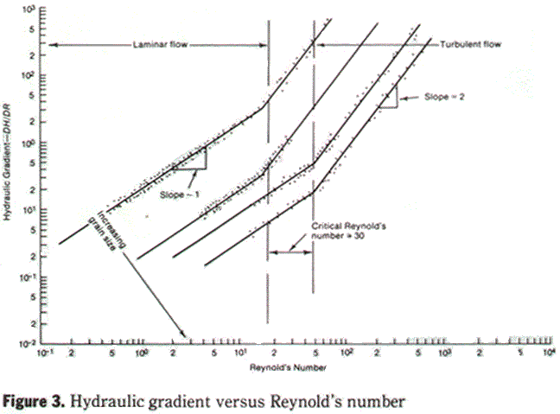
Based on the foregoing mathematical analysis and experimental results, a critical radius can be calculated for any given set of flow conditions. The critical radius is defined as that distance measured from the center of the well to the point where the flow changes from turbulent to laminar. Within the critical radius, flow is turbulent (or partially turbulent) with corresponding head losses varying as some exponential power of the velocity (approaching 2 for fully turbulent flow). Assuming a critical Reynolds number of 30, the critical radius may be calculated from:

in which r - critical radius - in. (m), Q/b = specific aquifer discharge - gpm/ ft (L/s/m), Q = well discharge - gpm (L/s), b = saturated aquifer thickness (assumed equal to screen length) - ft (m), d = characteristic diameter of material (50 percent passing size) - mm, and Ð = effective porosity of material (fraction).
Figure 4 is a plot of the specific aquifer discharge versus the critical radius for typical filter zone materials.
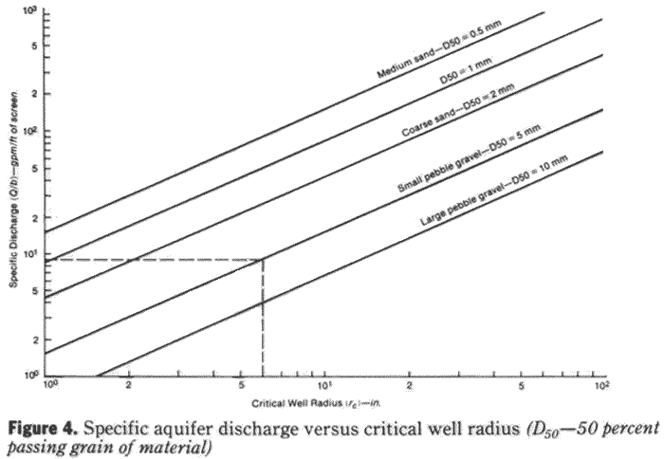
Components of drawdown in a pumping well. In a well fully screened throughout the aquifer or aquifers penetrated, the total drawdown is composed of laminar and turbulent head loss components. Laminar losses generally occur away from the borehole, at which point approach velocities are low, whereas turbulent losses are confined to the immediate vicinity of the well screen. Figure 5 shows the components of drawdown in a typical production well.
Total drawdown may be expressed as:
s = ds + ds' + ds'' + ds''' + minor losses (5)
in which s = total drawdown measured in the well, ds = laminar loss in the aquifer, ds' = laminar loss in the damage zone, ds'' = turbulent loss in the filter zone, and ds''' = well losses. Aquifer loss. The head loss (drawdown) measured at the interface between the aquifer and the damage zone is known as aquifer loss. The magnitude of aquifer loss can be determined from radial flow to the damage zone from the aquifer. Aquifer drawdown may be expressed quantitatively by the steady-state Theim equation:

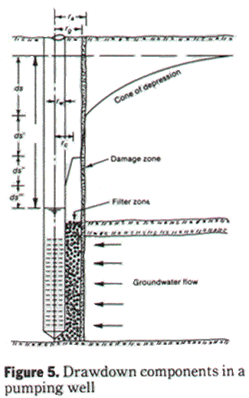
in which ds = drawdown in the aquifer - ft (m), Q = well discharge - gpm (L/s), K = aquifer hydraulic conductivity - gpd/ sq ft (mm/s), b = saturated thickness of the aquifer (assumed to be equal to length of well screen) - ft (m), r_{o} = radial distance from the center of the well to the aquifer-damage-zone interface - ft (m).
Head loss through the damage zone. The damage zone consists of finely ground drilling debris, wall cake, or other materials whose hydraulic conductivity is considerably less than that of the aquifer. Its condition depends on the quality of well construction and development. Head loss through the damage zone is generally laminar and may be expressed in a manner similar to aquifer loss:

In which ds' = head loss through the damage zone - ft (m), B' = damage zone loss coefficient - ft/gpm (m/L/s), r_{g} = radial distance to the inner edge of damage zone - ft (m), and r_{a} = radial distance to the aquifer-damage-zone interface - ft (m).
Turbulent losses in the filter zone. Turbulent flow losses will occur if the critical radius exceeds the nominal well radius and may be a significant component of total drawdown. These losses do not obey Darcy's law and vary exponentially with the flow velocity. Because of the patchy nature of turbulent flow in porous media, laminar as well as turbulent flow will probably occur. In pure laminar flow, i.e., Stokes flow, the stream lines are independent of flow speed, and non-linear terms in the Navier- Stokes equation are insignificant. Conversely, for pure turbulent flow, the stream lines depend on the speed of the flow, and the non-linear terms in the Navier- Stokes equations are important. The transition between pure laminar and pure turbulent flow in any given situation is not a sharp line, and partial turbulence is found in the transition between the two flow regimes. In this zone of partial turbulence, the exponent of the velocity used in calculating head losses may vary between 1 (for pure laminar flow) and 2 (for pure turbulent flow). The existence and degree of these losses depends on filter material, screen length, and pumping rate. Turbulent (nonlaminar) filter zone losses may be written as:
ds'' = B''Q''
In which ds'' = turbulent head losses in the near-well filter zone - ft (m), B'' = turbulent filter zone loss coefficient - ft/ gpm (m/[L/s]''), and n = exponent (1<n< 2).
Well losses. Head losses associated with the entrance of water through the well screen and the axial flow of water toward the pump intake are known as well losses. These losses are caused by turbulent flow conditions and vary as the square of the velocity. Well losses can be expressed as:
ds''' = CQ₂
in which ds''' = well losses - ft (m) and C = well losses coefficient - ft/gpm2 (m/[L/s]2). The majority of loss occurs as water jets through the screen openings.
Minor losses. In addition to the major drawdown components, several minor losses occur. Laminar losses through the filter zone and head losses associated with a restricted inlet area (e.g., convergence of flow lines toward milled slots) are typical minor losses. Generally, much smaller than other well losses, they are neglected in the total drawdown equation.²
Effective well radius. As defined by Jacob,³ effective well radius is that distance measured radially from the axis of the well at which the theoretical drawdown equals the actual drawdown in the filter zone. It shows the effectiveness of well development on increasing the hydraulic conductivity in the immediate vicinity of the well (Figure 6). Effective well radius may be calculated from step-drawdown test data once transmission and storage capacities of the aquifer are known.
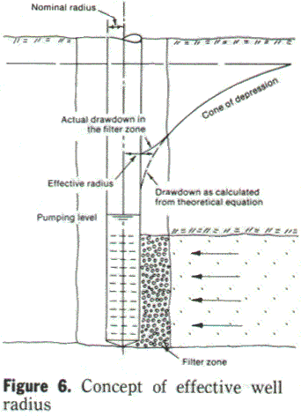
The following calculation can be used to evaluate well development:

in which r = effective well radius - ft (m), B = B (r_{e'} t*) = formation loss coefficient determined from step-drawdown testing - ft/ gpm (m/L/s), t* = time since the beginning of each new discharge step in the step-drawdown test analysis - days, T = transmissivity gdp/ft (²/d), and S = storage capacity.
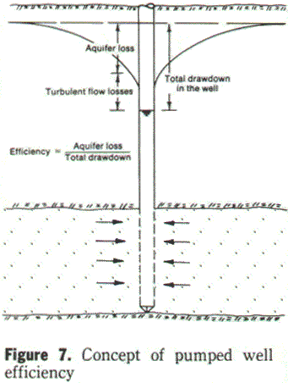
Pumped well efficiency. Well efficiency is the ration of the drawdown in the aquifer formation to the drawdown in the well. In a 100-percent efficient well, the total dynamic head required to lift the water to the initial (nonpumping) level would equal the total resistive (laminar) losses in the aquifer. This ideal well rarely exists in practice, with the exception of unscreened wells in fractured rock aquifers or cavernous limestone. Most wells exhibit turbulent losses through and near the screen, resulting in a loss of efficiency (Figure 7).
Well efficiencies considerably less than 100 percent are usually a result of a combination of damage-zone laminar losses and near-well turbulent flow losses. A combination of improper construction, poor filter pack, and screen design can result in partially or completely plugged screen slot openings, which cause extremely high losses in the vicinity of the slot and across the screen as well as very poor well efficiency.
Well efficiency may be quantitatively defined as:
E = BQ/ (BQ + B'Q + B"Q" + CQ²)100 (11)
In which E = pumped well efficiency - percent, B = formation loss coefficient - ft/ gpm (m/L/s), B' = damage zone loss coefficient - ft/ gpm (m/L/s), B" = filter zone turbulent flow loss coefficient - ft/ gpm'' (m/[L/s]²), Q = well discharge - gpm (L/s), and n = exponent (1<n<2).
In a properly constructed and fully developed well, the damage zone loss (ds') approaches zero. Equation 11 is similar to Jacob's classical definition of well efficiency with the addition of the turbulent filter and damage loss terms.
Step-drawdown tests are used to determine the coefficients B, B", and C; n is usually assumed equal to 2. Interference testing (in conjunction with the step-drawdown test) is used to determine the damage zone loss coefficient B'.

Design of Efficient Wells
Several design factors that affect hydraulic performance should be considered in the construction of a production water well. The most important of these are well development, screen length and diameter, filter zone material, and critical well radius. The degree to which each of these factors contributes to well performance depends to a certain extent on operational criteria (i.e., pumping rate) and to some extent on each of the other factors.
To properly design a well, the various factors should be evaluated with regard to initial cost as well as operational costs over the lifetime of the well.
Effect of well development. Well development is the process whereby material in the near-well zone is rearranged and fines are removed to produce a highly permeable filter. This includes the removal of any residue from formation damage, such as mud cake and invasion.
A well is considered fully developed when no further improvement can be obtained in specific capacity and well efficiency at a particular design discharge. Also, maximum allowable sand production must be achieved at a specified time after startup under permanent pump production rates. Figure 8 illustrates the effect of well development on both specific capacity and well efficiency.
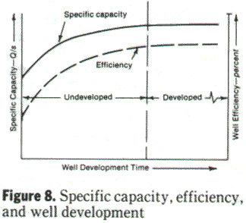
Effect of well screen length. The single most important design factor that directly affects well production is probably the length of the well screen. The importance of this parameter is supported by the steady-state equation for drawdown in the aquifer. In terms of specific capacity, this equation may be written:
Q/s = Kb/(528log [r_{o}/r_{e}]) (12)
in which Q/s = specific capacity of the well - gpm/ft (L/s/m), Q = well discharge - gpm (L/s), s = drawdown in the aquifer - ft (m), b = length of screen (assuming a fully penetrating well) - ft (m), K = hydraulic conductivity of the aquifer - gpd/sq ft (mm/s), r_{e} = effective well radius - ft (m), and r_{o} = radius at zero drawdown - ft (m). As Eq 12 shows, specific capacity is directly proportional tot he total length of screen installed in the aquifer.
Near-well turbulent losses as a function of screen length. A more efficient design can be assured by calculating the minimum length of screen required. If enough screen is provided so that the critical radius (r_{c}) is equal to or less than the nominal radius (r_{w}), turbulent-flow head losses in the filter zone can be minimized.
Sample calculations. Suppose it is desirable to pump 2000 gpm (126 L/s) from a 12-in.- (300-mm-) diameter well in an aquifer in which mechanical grading analyses show a 50-percent passing grain size (D₅₀) of 1 mm. A pack-to-aquifer ratio of 5:1 is selected , resulting in the filter material having an average grain size of 5 mm. The specific aquifer discharge for a critical radius of 6 in. (150 mm) is determined from Figure 4 to be 9 gpm/ ft (1.9 L/s/m). Therefore the minimum length of well screen (b) that is required to eliminate turbulent filter zone head losses would be:
B= 2000 gpm/ 9 gpm/ ft = 222 ft
For screen lengths shorter than 222 ft, the critical radius exceeds the nominal radius, creating near-well turbulent head losses. These additional head losses mean higher pumping lifts and operating costs over the life of the well. For example, if only 150 ft (45 m) of screen were installed, the specific aquifer discharge (Q/s) would be (2000/150) = 13 gpm/ ft (2.7 L/s/m). From Figure 4, the critical radius (r_{c}) is determined to be 10 in. (250 mm). In this case, turbulent flow would extend 4 in. (100 mm) into the filter zone, resulting in unnecessary turbulent head losses.
Effect of screen entrance velocity on well efficiency. There have been considerable discussion and controversy regarding the upper limit for screen entrance velocity corresponding to good well design. Recent investigations have produced valid data which refute earlier conceptions of the empirical relationship between head losses through screens and entrance velocities.¹
Throughout the testing it was apparent that below a certain entrance velocity no appreciable gain in well efficiency was achieved. This maximum value is 2-4 fps (0.6-1.2 m/s) and can be seen in part B of Figure 9. The upper velocity limit was obtained for model well efficiencies measured at 100-gpm (6.3 L/s). For this study the 100-gpm (6.3 L/s) model value was selected as a worst case or upper limit for field conditions because 100 gpm (6.3 L/s) in the model corresponds to a 600-gpm (37.9-L/s) well in the field pumping from a 5-ft (1.5-m) thick aquifer.
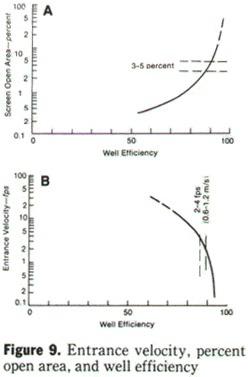
Correspondingly, the percentage open areas for the various screens tested were plotted against well efficiencies at 100 gpm (6.3 L/s). As shown in part A of Figure 9, the percentage open area corresponding to the 2-4 fps (0.6-1.2 m/s) to maximize well efficiency.
In most field installations, entrance velocity is well below this upper limit, as the following example shows. A well with 100 ft (30 m) of 10-in.- (250-mm-) diameter screen having 3- percent open area is pumped at 1000 gpm (63.1 L/s). The entrance velocity through the screen can be calculated from:
V = Q/(235r_{w}bP)
in which v = screen entrance cvelocity - fps (m/s), Q = well discharge - gpm (L/s), r_{w} = radius of the well screen - in. (mm), b = length of the well screen - ft (m), and P = percentage open area of the screen (fraction). From Eq 13 the entrance velocity is calculated as:
v = 1000/(235 5 100 0.03) = 0.28 fps
The example shows that even if the discharge from the well was increased by a factor of 10 (a highly unlikely field situation), the calculated entrance velocity would still be below the recommended maximum.
Effect of screen entrance velocity on corrosion. According to Rossum,^{4,5}velocity has two opposing effects on corrosion. Corrosion is initially accelerated by increasing velocity. As velocity increases, the thickness of the laminar flow layer adjacent to the metallic surface decreases, causing oxygen to diffuse from the metal. However, when protective films such as calcite, or siderite form, velocities up to 5 fps (1.5 m/s) promote denser and more protective coatings. In fact, within this range, the higher the velocity, the better the coating. Excessive velocities may result in a combination of corrosion and erosion that may be severe. This occurs when the protective coatings are swept away as they are being formed. For steel pipes, this velocity is approximately 10 fps (3 m/s).
Water system operators know that reasonable velocities are essential in mitigating corrosion. Where velocity is low, particularly in dead ends, corrosion is severe. Merrill and Sanks⁶ state that one of the attributes of a well-conditioned water supply is a velocity of at least 2 fps (0.6 m/s). Well photo and TV logs show that corrosion and encrustation are greatest in screens set opposite aquifers in which production and entrance velocities are low.
Effect of filter zone material and thickness. The primary purpose of the filter zone is to stabilize the aquifer. The well screen is correspondingly designed to stabilize the filter. In naturally developed wells, the filter zone is developed by removal of fine particles , leaving a zone of high conductivity surrounding the well screen. In filter pack wells, the relationship between a characteristic grain size (usually the 50-percent passing size) of the pack and that of the aquifer is known as the pack- aquifer ratio. There is general agreement that pack- aquifer ratios should be between 4:1 and 6:1. Uniformity of material as measured by the uniformity coefficient C_{u} (ratio of the 60-percent passing to the 10-percent passing grain size) does not seem to be a critical design factor if proper pack- aquifer ratios are adhered to. For example, tests have shown that highly nonuniform aquifers (e.g., C_{u} = 8) are stabilized using uniform filter packs (C_{u} = 1.5) if pack- aquifer ratios are between 4:1 and 6:1.⁷
The width of the annulus between the casing-screen and the borehole should be sufficient to facilitate installation of the filter pack. The thickness of a filter pack typically ranges from 4 to 6 in. (100 to 150 mm).
Although the grain size of the filter pack material also has an effect in the amount of near-well turbulence (i.e., smaller pore spaces reduce turbulence), control of turbulent flow losses is usually accomplished by reducing the pumping rate and increasing the screen length or diameter.
Effect of well screen diameter. Although screen diameter is not a critical design factor in most cases, it can affect well performance.
Effect of diameter on well losses. For screen diameters used in typical wells, the head losses that occur as water moves axially toward the pump intake are generally small. However, using high pumping rates with small screen diameters may result in significant frictional pipe head losses, and this possibility should be taken into consideration by the well designer.
Effect of diameter on critical radius. Under some conditions small diameters result in the phenomenon of near-well turbulence, with a corresponding loss in specific capacity. Therefore, screen diameters should be selected to ensure that the nominal well radius equals or exceeds the critical radius.
Effect of diameter on specific capacity. The following example illustrates the effect of screen diameter on specific capacity. For a 12 -in.- (300-mm-) diameter well in an aquifer with a transmissivity (Kb) of 100 000 gpd/ ft (1250 m²/d) specific capacity can be calculated from Eq 12. Assuming r_{e} = r_{w} and r_{o} = 1050 ft, Q/s = 57 gpm/ ft (11.8 L/s/m). If the well screen diameter was 24 in. (600 mm), the specific capacity would be: Q/s = 63 gpm/ ft (13 L/s/m). Therefore, doubling the diameter increases specific capacity only 10 percent.
Maximizing efficiency in well maintenance. Over the lifetime of the well, operational costs generally outweigh routine maintenance costs. Unnecessary operational costs result from screen and turbulent filter zone losses, plugging at the orifice, or loss of permeability in the filter zone. The importance of maintaining production and specific capacity is shown by the following sample calculation, in which annual annual operating costs are determined.
A well with an original drawdown of 100 ft (30 m) and a well efficiency of 80 percent at 2000 gpm (126 L/s) was tested for efficiency. The latest data showed a total drawdown of 117 ft (35 m) and a well efficiency of 68 percent at 2000 gpm (126 L/s). the additional operating costs resulting from this decline can be calculated as follows:
Original drawdown = 100 ft
Original formation losses = 80 ft = 0.8 100 ft
Original turbulent- flwo losses = 20 ft = 0.2 100 ft
New drawdown = 117 ft
New formation losses = 80 ft
New turbulent-flow losses = 37 ft = 117 - 80 ft
The additional head loss due to screen-slot plugging or other factors amounts to 17 ft (5.1 m). The number of kilowatts of power P required to lift this additional 17 ft (5.1 m), assuming a wire-to-water efficiency e = 0.65, can be calculated from:
P = = 9.854 kW
If the well is operated 16 h/d at a cost of $0.08/ kW h, the additional annual operating cost due to the efficiency decrease would be:
16 365 9.854 0.08 = $4604
Assuming a 15-year life, these additional costs amount to $69,060. Thus lower cost of operation is a primary benefit of maximizing well efficiency. Production and drawdown measurements should be conducted periodically and decisions made to redevelop the well should efficiencies decline below an acceptable operating level.

Field Tests
Step-drawdown tests to determine well-pump characteristics. Evaluations of efficiency and development, determination of drawdown- yield relationships, and calculation of some types of individual losses may be made by conducting step- drawdown tests on the well. The test procedure involves operating the well at multiple discharge rates, with each step being a fraction of the maximum discharge. At least three steps are necessary for testing most wells. If turbulence in the filter zone is suspected, however, as many as six steps may be required. Figure 10A illustrates a typical step-drawdown analysis for determining well-pump characteristics.
Analysis of the step-drawdown data requires plotting the specific drawdown s/Q for each of the steps. The following explanation shows the theory behind step-drawdown analysis. In a fully developed well penetrating the complete thickness of the aquifer, the drawdown in the well may be written as:

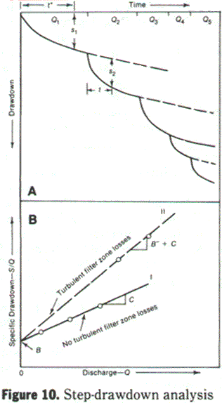
S = BQ + B"Q" + CQ2
in which s = drawdown as measured in the pumping well - ft (m), Q = well discharge - gpm (L/s), B = formation loss coefficient - ft/gpm (m/L/s), B" = filter zone turbulent flow loss coefficient - ft/gpm^{n} (m/[L/s]^{n}), C = well loss coefficient - ft/ gpm² (m/[L/s]²), and n = exponent varying between 1 and 2. Equation 14 may be rewritten in terms of s/Q, assuming fully turbulent flow in the filter zone (i.e., n = 2):
s/Q = B + (B" + C)Q
From Eq 15, it can be seen that the formation loss coefficient B may be determined from the zero intercept of the best-fit straight line on a plot of specific drawdown versus discharge. During low-discharge steps there probably will not be any near-well turbulence (i.e., B" = 0). Consequently, the only turbulent losses will be well losses. The slope of the best-fit straight line through these points will be equal to C (line I on Figure 10B). During higher discharge rates, any near-well turbulent flow losses will be reflected by a gradual change in slope (line II on Figure 10B). The slope of the curve steepens as turbulence increases, with head losses approaching those for fully turbulent flow. The slope of the best-fit straight line through the range of these points is equal to B" + C within the relevant discharge range.
In most wells, screen lengths are sufficiently long, and the critical radius does not exceed the nominal radius. When all points of the test lie on a straight line, this is confirmed. If additional drawdown does not yield an increase in production, a pointof critical discharge has been reached. This occurs when the screened formation is incapable of producing more water because of its internal resistive forces, or when the discharge is equal to or greater than recharge to the aquifer (e.g., boundary effects). This can, but usually does not, take place before the incidence of significant well or near-well turbulent flow losses.
Once the constants B, B", and C are determined, the well efficiency may be calculated for the complete range of discharge as:
no near-well turbulence
E_{I} = 100/(1 + CQ/B) (16)
Near-well fully turbulent flow present
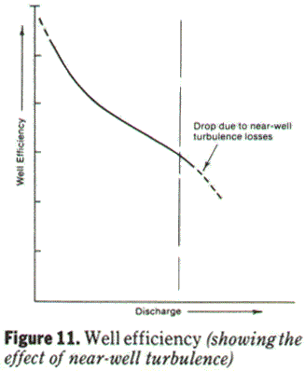
E_{II} = 100/(1 + [B" + C] Q/B) (17)
in which E_{I} = well efficiency during the lower discharge steps when no near-well turbulence is evident, and E_{II} = well efficiency during the higher discharge steps when near-well fully turbulent flow losses are present (Figure 11).
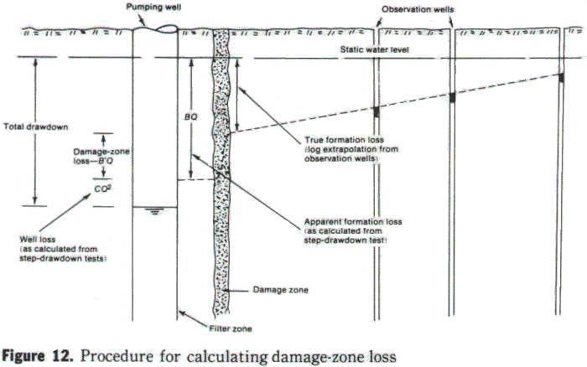
This testing procedure described applies only to fully developed wells with no damage-zone losses. Analysis of step-drawdown data on a well with damage-zone losses will result in a lower formation loss coefficient B than the true value. Step-drawdown testing by itself is not adequate to differentiate between types of laminar losses in the near-well zone. For those wells with known or suspected damage-zone losses, the following procedure is suggested. Identification of damage-zone head losses may be accomplished using an interference test in conjunction with the standard step-drawdown test. The interference test provides distance-drawdown data from observation wells located near the pumping well (preferably within several hundred feet [meters]). These data are then extrapolated logarithmically to the outer edge of the filter zone. This extrapolated drawdown at the aquifer-filter zone contact represents the true formation loss.
The difference between the apparent formation loss, as calculated from step-drawdown testing and the true formation loss, represents damage-zone laminar losses (Figure 12).
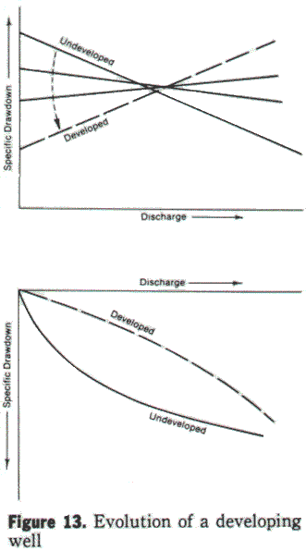
Step-drawdown tests to indicate stage of development. The step-drawdown test is also a valuable tool for determining at what point development is complete. Test data on newly developed wells forma base signature for the well. Subsequent tests can then be compared with the original data for redevelopment.
During development, the hydraulic conductivity of the material immediately surrounding the well increases as a result of removal of fine-grained material. In addition, development removes the detrimental effects of drilling. Therefore, both the damage loss term and the filter laminar loss term continue to decline during development. Step-drawdown tests conducted at during development reflect these declining head losses. Negative slopes on a plot of specific drawdown against discharge indicate development is occurring. Figure 13 typifies the evolution of a developing well.
Specific loss. Well efficiency tests have been shown to be useful to assess the condition of a well. But because the formation loss coefficient B is a function of aquifer type, comparison of well efficiencies between wells in different geohydraulic environments may be misleading.
To overcome this, the effect of the different aquifer types is removed and comparisons are made only between turbulent head loss terms (well losses and near-well turbulent head losses). This latter index, defined as specific loss (SL), is expressed as:
Specific loss = SL = CQ (no near-well turbulence)
For cases in which near-well turbulence is present, the specific loss can be written:
Specific loss = SL = (B" + C)Q
Figure 14 shows an example of two wells completed in dissimilar geohydraulic environments. As shown in the figure, comparisons of well efficiencies is misleading, whereas specific loss comparisons are meaningful.

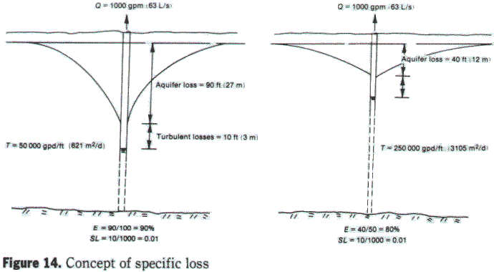

Conclusion
Design of efficient water wells requires knowledge of the various hydraulic factors that affect the major drawdown components. Turbulent flow through the well screen and in the near-well filter zone creates unnecessary head losses. Minimizing these turbulent-flow losses can result in substantial cost savings over the lifetime of the well.
Efficient wells incorporate proper design of screens and filter materials with effective development methods. The effective well radius can be used to measure the degree of filter-zone development. Estimates of the minimum length of well screen required to eliminate near-well turbulence can be made from knowledge of pumping rates and filter material. Recent experimental test results show that entrance velocity and screen open area are not critical design factors for mostfield applications. Proper pack-aquifer ratios and well development are primary factors in the construction of efficient water wells. The step-drawdown test is an effective tool with which to calculate the efficiency of a well and ensure that development is complete.

Acknowledgements
This research was funded by the Roscoe Moss Co. of Los Angeles, Calif. Special thanks go to Dave Walker and John List.

Bibliography
HANTUSH, M.S. Hydraulics of Wells. Advances in Hydroscience. Academic Press, New York (1964).
HANTUSH, M.S. Personal communication (1983).
HELWEG, O.J.; SCOTT, V.H.; & SCALMONINI J.C. Improving Well and Pump Efficiency. AWWA, Denver, Colo. (1983).
LIST, E.J. Analysis of Development Methods for Gravel Envelope Wells. The Roscoe Moss Co. (1983).
TODD, D.K. Groundwater Hydrology. John Wiley & Sons, New York (1980).

Footnotes
- WILLIAMS, D.E. the Well-Aquifer Model - Initial Test Results. The Roscoe Moss Co. (1981).
- BOULTON, N.S. Discussion in C.E. Jacob. Drawdown Test to Determine the Effective Radius of Artesian Wells. Trans.ASCE, 112:1047 (1947).
- JACOB, C.E. Drawdown Test to determine the Effective Radius of Artesian Wells. Trans.ASCE, 112:1047 (1947).
- ROSSUM, J.R. Personal Communication (1983).
- ROSSUM, J.R. Fundamentals of Metallic Corrosion in Fresh Water. The Roscoe Moss Co. (1980).
- MERRILL, D.T., & SANKS, R.L., Corrosion Control by Deposition of CaCO3 Films: Part 3, A Practical Approach for Plant Operators. Jour. AWWA, 70:1:12 (Jan. 1978).
- SMITH, H.E., Gravel Packing Water Wells. Water Well Journal, 8:1 (1954).

