The Well / Aquifer Model
Initial Test Results

Dennis E. Williams, Ph.D.

DENNIS E. WILLIAMS, a native of California, received his advanced degrees in hydrology and ground-water hydrology at the New Mexico Institute of Mining and Technology, where he studied under M.S. Hantush and C.E. Jacob. Following graduation he planned and directed geologic and hydrologic studies in the Owens and Mono basins with regard to the amount of surface and ground-water resources available to the city of Los Angeles. From 1971 to 1975 Dr. Williams was involved in the planning and execution of a number of groundwater projects in Iran. From 1976 to 1978 he was a consultant to the government of Iran as special advisor to the Ministry of Energy. He is also a consultant to the United Nations (UNDP). Dr. Williams currently serves as president of Geoscience Support Services, a company specializing in advanced technology consulting as applied to engineering and earth sciences.

Table of Contents
1.0 INTRODUCTION | 4
1.1 General Background Leading to the Development of the Well / Aquifer Model | 4
1.2 Specific Objectives of the Investigation | 4
1.3 Phases of Model Development | 5
1.3.1 Phases of Work | 5
2.0 BACKGROUND RESEARCH AND PREVIOUS WORK | 7
3.0 MODEL DESIGN AND CONSTRUCTION | 7
3.1 Physical Model Type | 7
3.2 Model Instrumentation | 9
3.2.1 Pressure Head Measurement | 9
3.2.2 Sand Measurement in Well Discharge | 10
3.2.3 Computer-Instrument Interface | 11
3.2.4 Control Computer | 11
3.2.5 Data Logging Cycle | 12
4.0 DESCRIPTION OF MODEL TESTS | 13
4.1 General Description of Test Methodology | 13
4.2 Initial Screens Used in the Testing | 13
4.3 Descriptions of Aquifer Materials Used in the Model Testing | 14
4.3.1 Santa Barbara Formation | 14
4.3.2 Silverado Aquifer | 15
5.0 THEORETICAL CONSIDERATIONS | 18
5.1 General | 18
5.2 Fundamental Parameters Affecting Flow Through Screens | 18
5.3 Pumped Well Efficiency | 23
6.0 ANALYSIS OF TEST RESULT | 25
6.1 Regression and Correlation Analysis | 25
6.2 Method of Analysis | 26
6.2.1 Data Groups | 27
6.2.2 Basic Regression Relationships Between Variables | 28
7.0 SIGNIFICANCE OF TEST RESULTS AS RELATED TO WELL DESIGN | 30
7.1 Concept of Effective Area of Opening | 30
7.2 Effective Well Radius | 31
7.3 Percentage of Screen Open Area, Entrance Velocity and Well Efficiency | 32
8.0 SUMMARY AND CONCLUSIONS | 33
9.0 ACKNOWLEDGEMENTS | 34

Table of Contents (cont’d)
Appendices
 |  |  | Page
I |  | Summary of Background Research | 35
II |  | Graphical Plots of the Regression and Correlation Analyses | 49
III |  | Basic Model Test Data From the First 25 Tests | 57
IV |  | Semi-logarithmic Plots of Water Level vs Distance for the Initial 25 Tests | 64
V |  | Computer Source Code Listings (Basic Language) for the Well/ Aquifer Model Data Logging Program | 69
VI |  | Computer Source Code Listings (Fortran IV Language) for Data Analysis and Plotting Programs | 69
Figures
1 |  | PERT/CPM Network Diagram of Model Development | 6
2a/2b |  | Time-scaled Network Of Model Development and Testing | 6-7
3 |  | Simplified Drawing of Well/ Aquifer Model | 8
4 |  | Location of Pressure Head Measuring Piezometers | 9
5 |  | Scanivalve Calibration Curve | 10
6 |  | Instrumentation Layout | 11
7 |  | Flow Chart of Model Data Acquisition System | 11
8 |  | Flow Chart of Model Data Logging Cycle | 12
9 |  | Mechanical Grading Analysis of the Santa Barbara Model Aquifer | 14
10 |  | Calculated Hydraulic Conductivity for the Santa Barbara Model Aquifer | 15
11 |  | Mechanical Grading Analysis of the Silverado Formation | 16
12 |  | Calculated Hydraulic Conductivity for the Silverado Model Aquifer | 16
13 |  | Well Screen Head Loss Sketch | 18
14 |  | Log-log plot of CL/D vs Head Loss Coefficient | 23
15 |  | Concept of Well Efficiency Showing Well Loss and Formation Loss | 23
16 |  | Summary Sheet of Initial 25 Tests | 27
17-23 |  | Summary of Regression and Correlation Analysis | 49
24-48 |  | Graphical plots of the Regression and Correlation Analyses (Appendix) | 53
49-73 |  | 49-73 Semi-logarithmic Plots of Water Level vs Distance for the Initial 25 Tests (Appendix) | 64
74 |  | Percentage Open Area vs Effective Well Radius | 32

The Well / Aquifer Model
Initial Test Results
Dennis E. Williams, Ph.D.

1.0 INTRODUCTION

1.1 General Background Leading to Development of the Well / Aquifer Model
Today, more than ever, energy plays a vital role in the planning and operation of any water resources development project. Providing safe, reliable ground-water supplies at the lowest possible cost requires careful design of all factors affecting the pumping and transportation water, from its source in the aquifer to its final destination and use.
Minimizing energy consumption can result in huge operational savings over the lifetime of any water resources project. One example of energy waste is the head loss associated with the entrance of ground water into the well. Minimizing this head loss requires careful consideration of the relationships between aquifer and gravel pack materials, well screen characteristics and location, and pumping rates.
Understanding the laws and principles governing these interrelationships is the subject of extensive research currently being conducted by Roscoe Moss Company of Los Angeles. The need for a study of this type and magnitude has long been overdue in the ground-water profession. Too often, critical factors affecting the design and construction of water wells are being obtained from unverified general assumptions, outmoded techniques, or application of methods and values which clearly do not apply. Consequently, many wells continue to be improperly designed, with results ranging from marginal to complete well failure.

1.2 Specific Objectives of the Investigation
The purpose of this investigation is to study interrelationships between well screens, gravel packs, and aquifers, using both theoretical and experimental techniques, and to deduce the basic laws governing these relationships. The original objectives are summarized as follows:
- Determine the physical hydraulic relationships between screen entrance velocity, sand transportation, and gravel pack design. In conjunction with this, test the validity of the "opinion" by Bennison (page 26) that entrance velocities must be between 0.1 and 0.25 ft/ sec.
- Determine the effect of gravel pack design criteria on stabilization of aquifer materials and well development (e.g., void ratio, grain size and shape, uniformity coefficient, and percentage passing for various screen openings).
- Verification of Peterson’s basic design criteria (CL/D>60 for minimum frictional head losses (page 29) on a larger scale than his original test apparatus and with consideration to aquifer materials. This will also determine the effects of partial penetration and the resulting converging flow field.
- Determine velocity distribution along the well screen length and check the validity of Peterson’s statement (page 29) that most flow takes place at the discharging end of the screen through a length such that CL/D>6.
- Demonstration of the principle of increased drawdown (and higher pumping lifts due to partial penetration effects even though CL/D>6.
- Determine the importance of screen open area and geometry in development of the gravel pack and surrounding aquifer material.
- Investigate the effects of different types and density distribution of screen openings on stabilization of gravel pack and well efficiency.
- Develop well loss criteria for a practical range of commercially available well screens and compare well efficiencies of these screens for different gravel pack / aquifer ratios.
- Investigate the structure of the gravel pack immediately adjacent to the well screen for various types of screens(louver, wire wound, etc.), and determine whether screen geometry affects entrance velocities and well efficiency.
- Investigate the build-up and methods for removal of incrustations with various types of commercially available well screens.

1.3 Phases of Model Development
The phases of model development leading to the results presented in this report can be seen in the PERT/CPM network diagram (see Figure 1). A general summary of these phases is shown below with the time-scaled network shown in Fig. 2a / 2b.
1.3.1 Phases of Work:
- Initial Model Design, Building and Testing
  - Background literature research
  - Theoretical analysis
  - Basic design and supervision of model test apparatus
  - Instrumentation of model using computerized control
  - Initial testing and verification of general theory
- Verification of Objectives and Analysis of Results
  - Experimental procedures on major study objectives using variations of well screen, gravel pack, and pack / aquifer ratios to obtain results which would meet the specific objectives of the study.
  - Analysis of experimental results and development of new theoretical approaches to properly explain observed phenomena.
- Documentation of data derived from background research, theoretical analysis, and experimental procedure, with interpretation into a comprehensive reference which can be used by all involved in the ground-water industry.
- Investigation of corrosion or incrustation on various well screens. This final original objective may require continuous long term testing of the effect of different quality waters on various casing and screen materials.
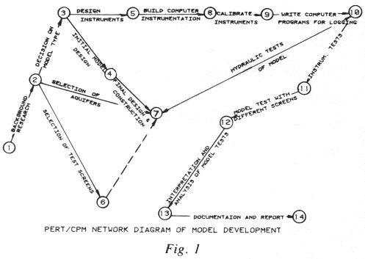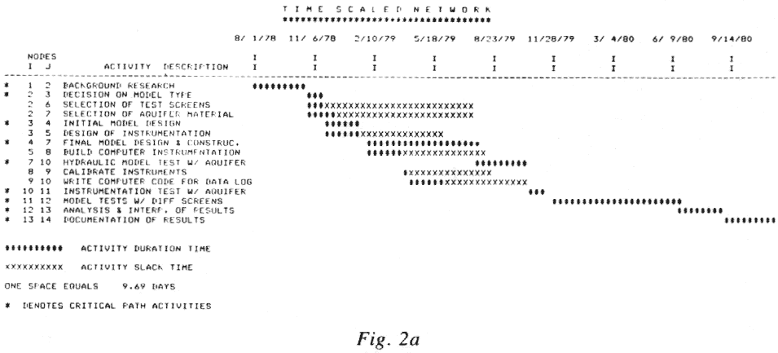
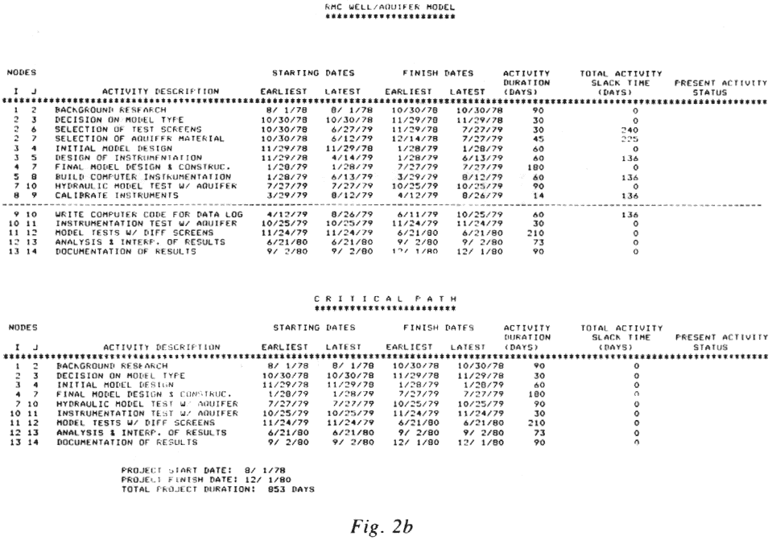

2.0 BACKGROUND RESEARCH AND PREVIOUS WORK
Prior to design of the well/ Aquifer model, an exhaustive literature search was undertaken on previous works relating to both theoretical and experimental procedures on well screens, gravel packs, and aquifer materials. Some of the more important investigations have provided guidance in this study, with some major conclusions or hypotheses incorporated into the present research. A summary of the more important investigations regarding hydraulics of well screens and gravel packs is included in Appendix I.

3.0 MODEL DESIGN AND CONSTRUCTION

3.1 Physical Model Type
The function of the model is to reproduce the operating components of production water wells. These include well screens, entrance velocities, gravel packs, and aquifers. These criteria necessitated building an apparatus that would reflect more of a prototype condition than a scaled down model. Thus, a wedge-shaped model 5 ft high and 12 ft long was conceived which represents a typical section of an aquifer having pure radial flow into a well. The sides of the prism represent those of an equilateral triangle with the internal angles being 60 degrees, or 1/6 the circumference of a well (see Figure 3). The physical dimensions of the model were designed to permit testing of commonly used well screens.

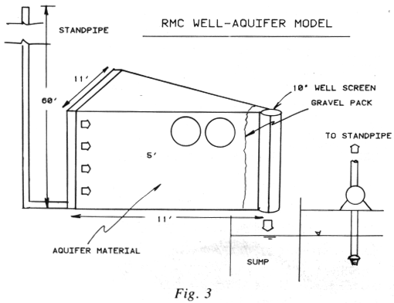
With model well screen diameter of 10 in. and a standpipe providing 60 ft of head (or drawdown) on the aquifer, a maximum model flow of 300 gpm is attainable using typical aquifer materials. This model flow is equivalent to 1800 gpm for a similar well in the field penetrating a 5 ft section of the same aquifer materials.
To achieve the strength required and prevent deflection, the frame was constructed as a welded one-piece tank. The top and one apex of the wedge are flanged and removable. They are heavily ribbed to withstand the potential of 150 ton hydraulic forces with minimal deflection. The three sides of the model are tied together with a network of steel bars spaced every 20 in. to maintain the stiffness required.
In order to prevent water from bypassing the aquifer along the top of the model (a common problem in sand tank models), an inflatable diaphragm was installed between the aquifer and the model top plate. Water pressure 4 to 6 psi higher than the aquifer system pressure is introduced into the diaphragm to prevent "channeling" along the top of the aquifer.
To simulate true field conditions, a "line drive" is created by introducing water uniformly into the entire 5 ft by 12 ft face of the aquifer using an entrance plenum. Aquifer material is prevented from entering the water-filled plenum by removable steel grates covered with perforated stainless steel sheets. Water enters the plenum through 8 in. diameter pipes located on both ends of the model. The ribs and beams are drilled for free flow, allowing unrestricted movement of water into the aquifer sand. Provision is also made for placement of a selected gravel pack up to 6 in. thick between the aquifer and well screen.
Water leaving the model through the well screen discharges into a below-ground sump and flows through a mesh into a second sump, where it is pumped through diatomaceous earth filters before returning into the model intake plenum. Any coarse sand or gravel pack material discharged through the well settles into the first sump.
The wedge-shaped prism design permits observation of the formation / gravel pack interface as well as the screen interior. Viewing ports along one side of the model reveal the aquifer and portions of the gravel pack. The viewing ports are made of 16 in. diameter, 1 ¼ in. borosilicate glass.
Observation of aquifer flow lines can be studied utilizing these viewing ports. Dye introduced into the aquifer material reveals flow lines relevant to different screen/ aquifer designs. Tempered borosilicate glass viewing windows permit observation of the inside of the test well screen, and conventional photographic studies of the well screen and flow characteristics are facilitated. The phenomenon of effective area of opening was first observed through these viewing windows.

3.2 Model Instrumentation
3.2.1 Pressure Head Measurement
New technology in the field of microelectronics was utilized to obtain the multitude of pressure flow, and sand particle measurements necessary to evaluate performance of the model well screen/ gravel pack/ aquifer combination. To measure hydraulic head throughout he model, forty-four ¼ in. piezometer tubes were placed in the aquifer and gravel pack in four horizontal planes, arranged logarithmically from the well bore. Figure 4 shows the location of the piezometers and their respective numbers as they are referred to in the data.
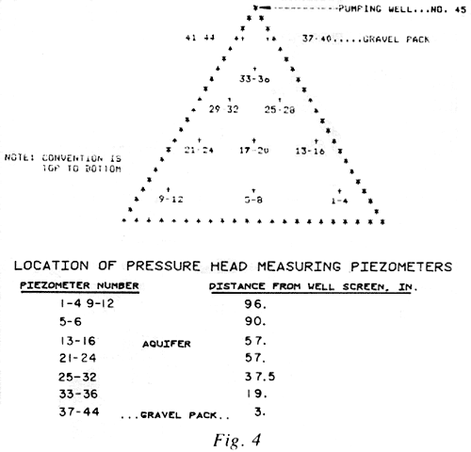
Location of the piezometers is permanently fixed by taping them to the rods and bottom of the frame. The ends of the piezometer tubes are covered with a filter material to prevent formation from entering and clogging the line.
In addition to the 44 piezometers in the aquifer and gravel pack, a 45th piezometer is located in the well. Two additional piezometers are installed in a venturi-type flow meter to provide data on the model flow rate. A rotating valve (Scanivalve) combined with a solid state pressure transducer sequentially measures the hydraulic head on each of the 47 ports.
Under control of a computer, the Scanivalve can be directed to take pressure readings of all the ports or an individual port. The input pressures range from 0-26 psi which correspond to a head ranging from 0-60 feet of water. Calibration of the Scanivalve was performed using a standard Dead Weight tester. Results showed an accuracy of 1 inch of water head (see Figure 5).
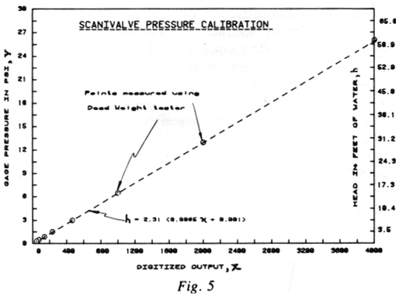
The Scanivalve pressure transducer output is an analog voltage ranging from 0-10 V dc. This voltage is converted to 12 binary bits using a Vector Graphics analog to digital converter. "Port" identification is effected through an optical encoder having a BCD (Binary Code Decimal) output.

3.2.2 Sand Measurement in Well Discharge
Sand Measurement in the well discharge is performed by a HIAC unit particle counter. In this system, particles of material in a sample stream of water pass through a 20 to 1000 micron sensor and are scanned by a collimated light beam. A photodiode coupled with advanced electronic circuitry counts individual particles. Resulting calculations of mechanical grading analysis and particle flow rates in parts per million (ppm) are easily determined.
The particle counter sensor is located close to the well (see Figure 6). A small flow is diverted from the well above the regulating butterfly valve. Output from the sensor is relayed to the HIAC particle counter where a BCD output of channel number and cumulative particle counts is read by the computer. Range is satisfactory for the size of particles produced from typical aquifers.
3.2.3. Computer Instrument Interface
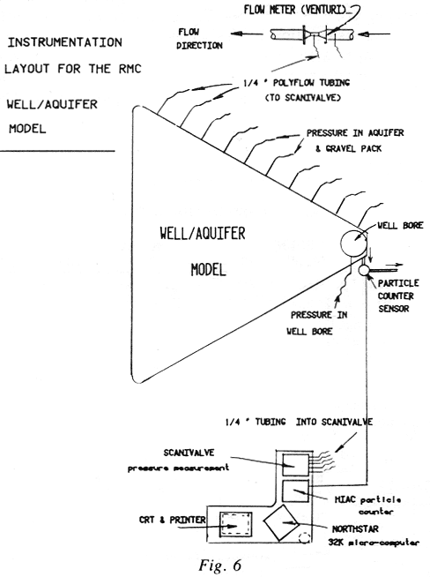
During any one data logging cycle, over 1100 bit of information on pressure and particle counts are relayed by a data multiplexer to the computer for storage and analysis. The multiplexer interfaces input data in an orderly fashion, enabling the computer to "read" all information through one 8-bit parallel input port (see Figure 7).

3.2.4. Control Computer
The heart of the data acquisition system is a 32K byte microcomputer manufactured by Northstar. The peripheral devices include two "mini-floppy" dual density single-sided disk drives with a 256K storage capability. Communication to the computer is through a SOROQ video display station. Hard copy output and graphic plotting of results is accomplished using an Integral Data Systems dot matrix printer.
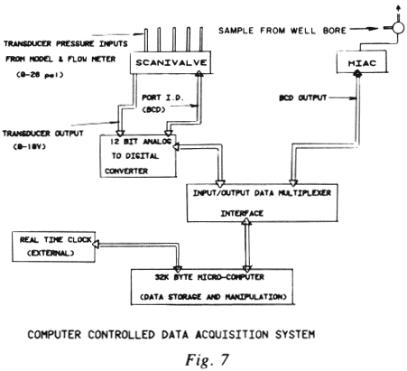
A real time clock circuit external to the computer was built to keep track of "time of day" necessary for the automatic data logging operation.

3.2.5 Data Logging Cycle
Figure 8 is a flow chart showing a typical data logging cycle during a model test run. Logging start time and frequency of measurements are coded in prior to start-up of the model run. The computer continuously reads the real time clock to see if it is time to take a reading. Each time a predetermined "log data" time matches the real time of day, the logging cycle is initiated, as shown in Figure 8. Thus, all the basic hydraulic characteristics of the test are immediately available on a "real time" basis or stored for future analysis and evaluation.

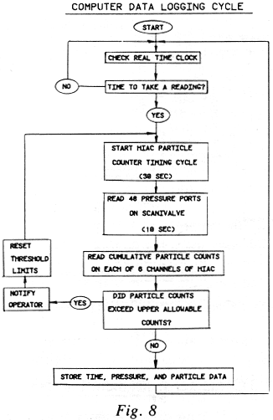

4.0 DECRIPTION OF MODEL TESTS

4.1 General Description of Test Methodology
A general testing procedure was standardized for the first series of 25 tests on the Santa Barbara and Silverado formations, using six different well screen types. This procedure consisted of the following:
- After installing the particular well screen to be tested, the model was allowed to reach steady state flow conditions. This stabilization, principally deaeration, usually took two to three days, during which time the newly installed well screen and gravel pack were developed to maximum capacity after reaching equilibrium conditions.
- A physical monitoring procedure was then initiated which consisted of taking the necessary series of pressure, flow, and sand content measurements. All piezometers were read using the automatic instrumentation procedures. The 44 piezometers selectively placed within the aquifer and gravel pack obtained the measurements necessary to determine the piezometer head distribution throughout the model. Two piezometers on either side of the venturi meter obtained flow data on well discharge. One piezometer located in the well itself reflected the actual pumping level. The Scanivalve instrument provided automatic data logging capabilities for pressure measurements. Sand content in the well discharge was measured using a HIAC particle counter. Equivalent parts per million of sand content were calculated.
All data logging operations were under supervision of a microcomputer with real time control capability.

4.2 Initial Screens Used in the Testing
Six different well screens were chosen for initial testing in the model. Screen choice was made with consideration to design as well as percentage of open area. A wide range was thought necessary to test the hydraulic flow characteristics as specified in the initial objectives of the well/ aquifer model. The following table gives a summary of the six screens used in the initial model tests.

SCREENS USED IN THE INITIAL TESTING
Screen Type | Open Area* (in²) | % Open Area
Continuous Wire Wrap | 364.0 | 34.00
Horizontal Louver Shutter Super Flo Pattern | 75.0 | 74.00
Vertical Bridge | 49.0 | 4.80
Horizontal Louver Shutter Full Flo Pattern | 35.0 | 3.40
Horizontal Louver Shutter Standard Pattern | 10.5 | 1.00
Vertical Miled Slots | 7.5 | 0.74
* Open area for all screens was based on 1/2 of a 10 inch diameter screen having a length of 5 feet with .060" apertures

All screens were initially prepared for model testing in an identical fashion, exposing half the screen to flow. In subsequent testing, two-thirds of the exposed screen section was masked to expose 60°. This latter series of tests resulted in a more realistic model / aquifer scaling ratio by eliminating the previous distortion of one-sixth of the aquifer flowing into one-half of the well. Masking the well screens was accomplished in a symmetrical fashion to provide for uniform exposure. Ordinary duct tape was used on the outside of the well screen to selectively block off portions of the screen apertures.

4.3 Description of Aquifer Materials Used in Model Testing
For initial model testing, it was felt that aquifer materials from field formations should be used as representative of prototype conditions. Two different aquifer materials were located which met the requirements. Both formations are well known producing aquifers, and have substantially different geohydraulic properties.

4.3.1 Santa Barbara Formation
The first aquifer material tested in the model was a Quaternary geologic formation common in the Santa Barbara area of California. The Santa Barbara formation is a "tight" fine-grained sand with low hydraulic conductivity, representative of the coastal area of California near Santa Barbara. Average grain size is .15mm and the uniformity coefficient is 1.3. The aquifer material was obtained from an outcrop location in Santa Barbara and installed in the model in Los Angeles. Following a sieve analysis (see Figure 9), tests using a "Darcy apparatus" were made, establishing an initial hydraulic conductivity of 50 gallons per day per square foot. Hydraulic conductivity as determined from model tests was somewhat lower, averaging 29 gpd/ ft² (see Figure 10).
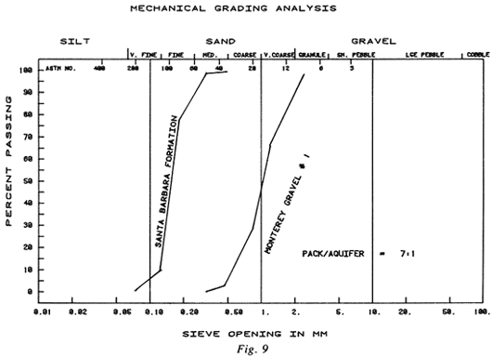
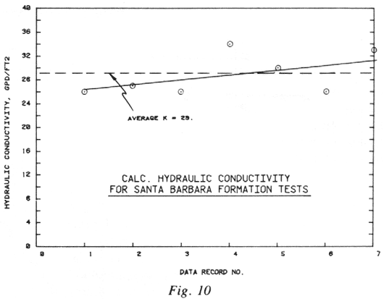
A gravel pack (Monterey #1) was selected to give a pack/ aquifer ratio of 7:1 (see Figure 9).
Due to the extremely low hydraulic conductivity of the aquifer material, only 2 gpm could be produced through the model, with maximum drawdowns at the well approaching 55 ft. This model yield of 2 gpm would be equivalent to a well in the field screened in 5 ft of aquifer producing 12 gpm. Field tests from the Santa Barbara area confirm these results.

4.3.2 Silverado Aquifer
The second series of model tests incorporated a much more permeable material known as the Silverado formation, which underlines much of the West Coast basin of Los Angeles.
The Silverado aquifer was obtained from a well under construction, using a mud scow, a drilling tool known for its ability to remove formation intact rather than pulverizing it.
Mechanical grading analyses of the Silverado formation used in the model, along with two different gravel packs, are shown in Figure 11. The difference between the field aquifer and the model aquifer can be explained by rearrangement of the material when introduced into the model. The average grain size of the Silverado model aquifer is .87mm with a uniformity coefficiency of 7.3.
The hydraulic conductivity of the Silverado aquifer as measured from actual model tests averaged 1166 gpd/ ft² (see Figure 12). This is 40 times more permeable than the Santa Barbara formation. Under 57 feet of drawdown, 76 gallons per minute were produced in one of the model tests. This is equivalent to 456 gpm from a well in the field screened in five feet of Silverado aquifer materials.
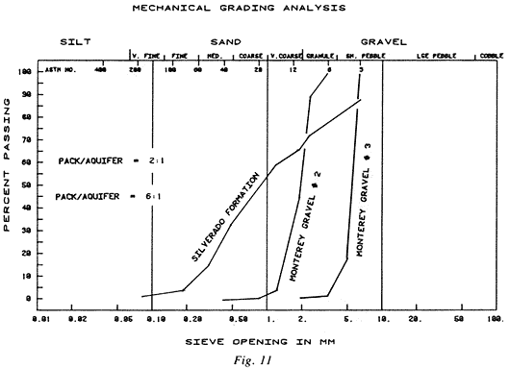
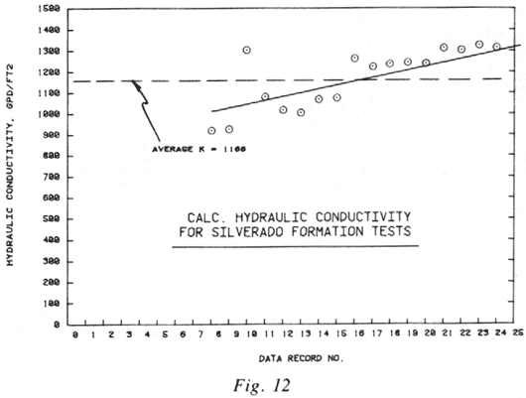
An interesting comparison to the model tests on the Silverado is revealed by pumping tests conducted on the well from which the formation was removed. In the production well, 200 feet of the Silverado formation was encountered. The well was constructed using cable tool techniques, with the casing jacked into the bore hole as the well was drilled. With this method, the casing is perforated after installation with a "down-the-hole" horizontal louver-type perforator.
The well was tested at 3,015 gallons per minute with a drawdown of 26 ft for a specific capacity of 116 gpm/ft of drawdown. The field hydraulic conductivity of the Silverado aquifer as calculated from this well was 2012 gpd/ft². This is 1.7 times higher than the model value and can be explained by the well sorted gravel layers existing in the field which were not duplicated in the model.
The percentage open area of the perforated casing was only 1%. A step drawdown test gave a well efficiency of 85% with entrance velocities of 0.95 ft/sec. Sand production was less than 3 ppm.
A summary of the model aquifers with their corresponding gravel pack characteristics is shown below:
Santa Barbara Formation (Tests 1-7)
D₅₀ = 0.15mm (50% passing grain size)
D₆₀ = 0.16mm (60% passing grain size)
D₁₀ = 0.125mm (10% passing grain size)
Uniformity coefficient: = 1.3
Montery Gravel Pack #1
D₅₀ = 1.04mm
D₆₀ = 1.14mm
D₁₀ = 0.54mm
C_{u} = 2.1
Pack/Aquifer ratio = 7:1

Silverado Formation (tests 8-25)
D₅₀ = 0.87mm
D₆₀ = 1.40mm
D₁₀ = 0.19mm
C_{u} = 7.3
Montery Gravel Pack #2 (tests 8-16)
D₅₀ = 2.00mm
D₆₀ = 2.11mm
D₁₀ = 1.31mm
C_{u} = 1.6
Pack/Aquifer ratio 2:1
Montery Gravel Pack #3 (tests 17-25)
D₅₀ = 5.43mm
D₆₀ = 5.64mm
D₁₀ = 4.09mm
C_{u} = 1.4
Pack/Aquifer ratio 6:1

5.0 THEORETICAL CONSIDERATIONS

5.1 General
One of the primary objectives of the initial series of tests was to understand the qualitative and quantitative hydraulic relationships that exist between the parameters that contribute to efficient gravel envelope water well design; these are the well screen, gravel pack, and aquifer materials. To understand these interrelationships requires utilizing the principles of fluid mechanics and the flow of fluids through porous media.
One advantage of using a model of this type is that qualitative and quantitative relationships may be developed from experimental observations alone, and rigorous mathematical theory is not absolutely necessary. However, a certain amount of mathematical background analysis should be done to understand the basic principles of hydraulics which result in the physical observations observed. This is not to say that these observations will necessarily conform to theory. On the contrary, the purpose of this research is to find out what significant relationships might occur, and to understand them. Mathematical analysis serves as a foundation upon which experimental observations and resulting analysis may be laid. It also is a tool used to confirm the validity of model analogy and test procedures.

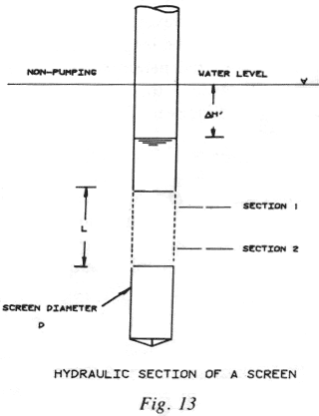
5.2 Fundamental Parameters Affecting Flow Through Screens
Flow through well screens can be thought of as analogous to flow through a series of orifices. As water enters, there is a conversion of potential energy to kinetic energy which is necessary in order to develop the jet velocity that drives the water through the individual screen openings. Once through the screen, the energy developed by the jet is completely dissipated and not recoverable either as kinetic or potential energy. The water then rotates in a direction parallel to the axis of the screen and accelerates toward the pump intake. This acceleration results in a change of the momentum flux. Here the flow resembles flow through a pressurized pipe conduit.
In conjunction with this movement of water into and along the well screen, a loss of hydraulic head occurs between the inside and outside of the well screen (see Figure 13). Quantitatively, this concept for the loss of head through a well screen can be expressed as
Where:
L = length of screen section [L]
D = screen diameter [L]
= pressure difference between inside and outside of screen [F/L²]
n = roughness coefficient of screen [Lº]
= mass density of the fluid [M/L³]
= dynamic viscosity of the fluid [FT/L²]
V = fluid velocity in well screen [L/T]
Ap = percentage open area of well screen [Lº]
Cc = coefficient of contraction of well screen openings [Lº]
By using principles of dimensional analysis and hydraulic similitude and choosing D, , and V as the repeating variables, equation (1) can be reduced to

Assuming inertial effects predominate in the problem of head loss through a well screen, with viscosity effects secondary, then the term of equation (2) representing the Reynolds number (VD/) can be eliminated in the first order approximation. Also, assuming that influence of the jetting action of the water is far more significant in loss than the frictional component of the water travelling axially in the screen, the term of equation (2) representing the roughness factor (n/D) can also be eliminated.
Equation (2) can now be written in terms of head loss as
Where
h = difference in piezometric head between the inside and the outside of the
screen [L]
One of the purposed of this investigation is to experimentally evaluate equation (3) by comparing head losses with open area percentages for different screen designs. However, in this first series of tests, no variation of screen length (L) was attempted, so that in all tests the parameter L/D was in fact a constant. Because of this, the basic relationship of equation (3) reduces to

Further theoretical analysis can be applied to the right-hand member of equation (4) by introducing principles of continuity, energy, and momentum. These principles are applied subject to the following assumptions:
- No acceleration takes place normal to the direction of flow.
- No variation in velocity takes place across screen sections.
- No internal resistance to flow exists.
The basic relationships can be written as
Continuity: Q = A₁ V₁ = A₂ V₂ (5)
Energy (Bernoulli’s equation):
Momentum:
Where:
Q = flow rate parallel to the screen axis
A = cross sectional area of the screen
g = gravitational acceleration
P/ = hydrostatic head
= fluid density
Z = distance from arbitrary datum plane
F = change in momentum along the axis of the screen (see Figure 13)
By combining the energy and continuity equations, the element of discharge dQ through the increment of screen length dL can be shown to be

Integrating equation (8) yields

Applying the momentum equation to the flow in the screen between sections 1 and 2 results in

Rewriting equation (10) in differential form

Assuming the piezometric head on the outside of the screen to be a constant

and

Equation (11) can now be rewritten as

Which upon integration gives

When Q = 0 then h = h’ (difference between the piezometric head between the inside and outside of the screen section at the point where L = 0). Also

Equation (15) can now be written as

Differentiating equation (17) with respect to length yields

Combining equations (8) (17) and (18) results in

Integration of equation (19) yields

where C = 11.31 Cc Ap
and C₂ = 0 (since h = h’ when L = 0)
Replacing h’ with the value from the equation (17) results in

In the present model geometry, is a constant for all tests calculating to be

Considering this, equation (21) reduces to

Simplifying equation (22) results in
where 6C = 67.86 Cc Ap
The coefficient of contraction of the screen openings can be obtained from

where: C = coefficient at discharge
and: C_{v} = coefficient of velocity =

Equation (24) can be rewritten as
where PS = fraction of total screen circumference open to flow
The actual velocity (V) through the well screen openings was not measured but was calculated from the discharge and maximum theoretical open area of the screen. Because of this, equation (25) will yield a value of Cc = 1.0 if the velocity as calculated from the continuity equation is used. This should be considered an upper limit with actual velocities yielding corresponding lower values of Cc.
As a first approximation, a value of Cc = 1 will be used in equation (23), resulting in
where:
Ap = PS
PS = fraction of screen open to flow
= maximum percent open area of actual well screens used in the tests for
½ screen open to flow
= 67.86 Ap
A log-plot of equation (25), Figure 14, shows a straight line over the range of the loss coefficient. Because of the constant CL/D value used in the first series of tests (CL/D = 6), the variation of the head loss coefficient vs screen length showed no significant results, but generally followed the theoretical trend as could be expected.
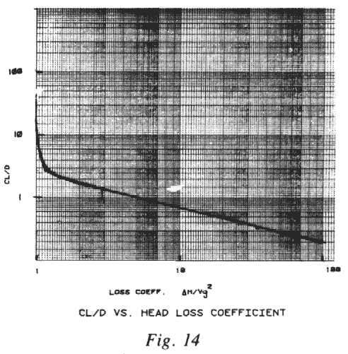

5.3 Pumped Well Efficiency
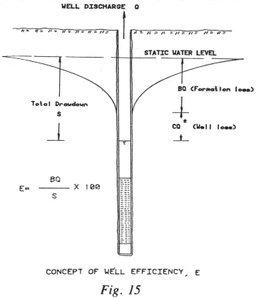
With consideration of all factors contributing to head loss as specified in equation (4), a less rigorous theoretical approach to the problem of screen loss can be formulated. To understand this latter approach, the concept of "well efficiency" must be introduced. This concept of pumped well efficiency was first presented by Jacob in 1947. Basically, Jacob defines well efficiency as the formation loss (the laminar head loss required to produce flow in the aquifer) divided by the total drawdown as observed in the well. This quotient is expressed as a percentage.
Figure 15 is a simplified sketch illustrating this concept. Since ground-water flow through porous media is laminar in nature, the head loss required to produce flow through the aquifer is proportional to the first power of the well discharge:
Formation loss = BQ
where:
B = formation loss coefficient
Q = well discharge
Formation loss is defined as the difference between the static (non-pumping) water level in the aquifer and the water level observed in the aquifer (or gravel pack) immediately adjacent to the well casing or screen.
As water enters a well through screen openings, its velocity increases as the jetting action produces a turbulent flow condition. The turbulence caused by the jetting action through the well screen, as well as the change in direction of the water as it is forced to move axially, results in an additional head loss term. Head loss associated with this turbulent flow is known as well loss and varies approximately as the second power of the discharge.
Well loss = CQ²
where C = Well loss coefficient
The formation loss coefficient (B) is related to aquifer characteristics, while well loss coefficient (C) is a function of well screen design, geometry, and effective area of opening. The total drawdown, observed in the well, can be stated as a sum of formation loss plus the well loss:
s = BQ + CQ² (26)
Well efficiency is a measure of effectiveness of well screen as a transmitting medium between the aquifer (or gravel pack) and the well. This effectiveness can be quantitatively expressed as
Pumped Well Efficiency:

Rearranging the above equation results in
Pumped Well Efficiency:

As can be seen in the above equation, well efficiency is not a constant but varies inversely with discharge (i.e., efficiency is maximum for low discharges and minimum for high discharges).
The well loss term (CQ) in equation (26) can be directly related to the velocity head term shown in the left hand member of equation (4) and in Bernoulli’s equation (6); namely,

Where K = a loss coefficient that is dependent upon the physical geometry of the
hydraulic structure (e.g., screen openings, or orifice shape and gravel
interface) through which water passes.
From the continuity principles, the velocity head loss can be related to well discharge by
Q = AV

From the above analysis, the similarity between the standard Bernoulli velocity head loss term and the well loss coefficient as seen in equation (6) is apparent. The coefficient (C) in equation (30), known as the well loss coefficient, is in fact a function of both the head loss coefficient (K), as defined by standard hydraulic terms, and other factors such as "effective screen open area."

6.0 ANALYSIS OF TEST RESULTS

6.1 Regression and Correlation Analysis
Considering the preceding theoretical discussion on well screen loss, the following fundamental parameters are significant:
(Q, Ap, V, E, H,, C) (31)
where:
Q = well discharge [L³/T]
Ap = percent of open area of screen [Lº]
V = screen entrance velocity [L/T]
E = well efficiency [Lº]
H = head loss across the screen [L]
= fraction of screen circumference open to flow [Lº]
C = sand concentration of well discharge [Lº]
In the initial testing using the Santa Barbara and Silverado formations, sand concentrations measured in the well discharge was insignificant for all 25 tests. Because of this, the sand concentration parameter was eliminated from the regression and correlation analysis in this report. Also, the fraction of well screen open to flow () is considered as a separate data group and was not included in the subsequent analysis. Equation (31) now reduces to the fundamental parameters
f(Q, Ap, V, E, H) (32)
From the variables in equation (32) it can be determined that a maximum combination of ten possible groupings will exist if the five basic variables are analyzed in groups of two:
where:
n = combination of variables (n = 5)
r = selection out of the n objects with no attention given to the order of arrangement (r = 2)
or
₅C₂ = 10
Therefore, of the significant parameters measured in the first series of tests, there is a total of 10 possible groupings of variables upon which regression and correlation analysis can be performed. The regression, or estimation of one variable (the dependent variable) on another (the independent variable), for the 10 maximum combinations, is the subject of the following section. The degree of relationship between the variables, or the indicator that tells how well the regression equation describes or explains the relationship, is quantitatively measured using correlation analysis.
For the variables in equation (32) only simple regression and correlation was used. The purpose of the analyses was twofold:
- To verify existing known relationships (e.g., h vs V) and show that model analogy and test procedures were valid.
- To establish new relationships by experimental observation and analysis which could lead to better understanding the basic factors affecting well design.

6.2 Methods of Analysis
Three types of simple regression were used to analyze the 25 test results from the Santa Barbara and Silverado aquifers:

These three equations were fit to the observed test data using the method of Least Squares. In order to quantitatively measure the degree of explained or unexplained variations between the variables, the correlation coefficient (r) was calculated, namely:

or

where:
Yest = estimated value of dependent variable.
= mean value = Y/N
Y = actual or measured value as obtained from test data
N = number of observations
From equation (35), the unexplained variation can be derived to be

The following analysis consists of calculations of simple regression and correlation for all the variables of equation (32) as well as the unexplained variation.

6.2.1 Data Groups
Raw data from the initial 25 tests on the Santa Barbara and Silverado aquifers are shown in Appendix II. A summary of this information is shown in Figure 16. Because of variations in test parameters, distinct groupings of tests were selected for the regression and correlation analyses. Seven separate groupings of the individual tests were selected and are shown below:

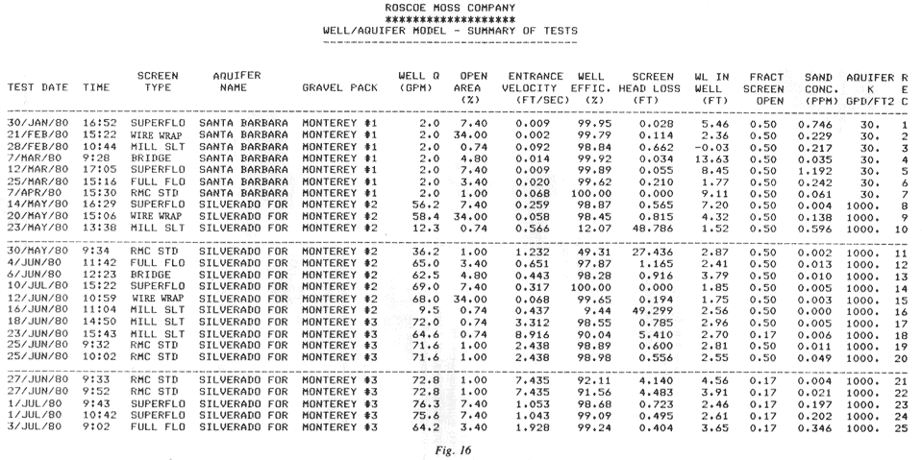

Data Groups Used in the Regression and Correlation Analysis
Data Group | Explanation | Data Records*
1 | All tests on the Santa Barbara formation | 1-7
2 | All tests on the Silverado formation | 8-25
3 | Silverado formation (all tests with 180⁰ of the screen open to flow) | 8-17, 19, 25
4 | Silverado formation (all tests except data records 10, 11, 16) | 8,9, 12-15, 17-25
5 | Silverado formation (all tests with 60⁰ of the screen open to flow) | 18, 21-25
6 | All tests on both the Santa Barbara and Silverado formations | 1-25
7 | All tests on both the Santa Barbara and Silverado formations except data records 10, 11, 16 | 1-9, 12-15, 17-25
* See summery sheet (Figure 16) for identification of data records.
The data groups were chosen based on distinct test conditions such as similar aquifer types and screen open area. Due to an unusual combination of gravel and screen type, 3 of the 25 tests showed unstable results, (data records 10, 11, and 16). In these tests, since full development was not complete, resulting data are not representative of the true hydraulic characteristics of the particular test.

6.2.2 Basic Regression Relationships Between the Variables
In the correlation and regression analyses, the physical relationship between the variables can be described as follows:
- Discharge (Q) vs Percent Open Area (Ap)
Fundamental relationship: Q = Ap V
Regression type = Linear
- Discharge (Q) vs entrance velocity (V)
Fundamental relationship: Q = Ap V
Regression type = Linear
- Well efficiency (E) vs discharge (Q)
Fundamental relationship: E =
Regression type = Hyperbolic
- Discharge (Q) vs Screen Loss (h)
Fundamental relationship:
Regression type = Linear
- Entrance velocity (V) vs % open area (Ap)
Fundamental relationship:
Regression Type = Hyperbolic
- Well efficiency (E) vs % open area (Ap)
Fundamental relationship:
Regression type = Hyperbolic
- % open area (Ap) vs screen loss ( h)
Fundamental relationship:
Regression type = Linear
- Well efficiency (E) vs entrance velocity (V)
Fundamental relationship:
Regression type = Hyperbolic
- Screen head loss ( h) vs entrance velocity (V)
Fundamental relationship:
Regression type = Parabolic
- Well efficiency (E) vs screen loss ( h)
Fundamental relationship:
Regression type = Hyperbolic
Figures 17 through 23 show results of regression and correlation analysis on the five significant variables (Q, Ap, h, E, V) using the combination analysis described in section 6.1. The regression of the Y variable on the X variable was performed using both linear as well as the regression type discussed in section 6.2.2. Correlation coefficients were calculated and the unexplained variation delineated as an indicator of the "Goodness of fit" of the regression. Those regressions having unexplained variations of 15% or less were considered significant and were chosen for graphical plotting. These are shown in Figs. 24 through 48 (Appendix II).

7.0 SIGNIFICANCE OF TEST RESULTS AS RELATED TO WELL DESIGN

7.1 Concept of Effective Area of Opening
An important observation resulting from the initial testing occurred during the 10th, 11th, and 16th tests (see Figure 16 and data records 10, 11, and 16 in Appendix III). In these three tests, a combination of variables produced a unique hydraulic situation in the well/ aquifer model. The aquifer type in the model was the Silverado formation, and the gravel pack was Monterey #2 (see Figure 11). The resulting pack/ aquifer ratio was 2:1.
The well screens tested had an opening fraction of 50% (i.e., 180⁰ or half the screen open area was available for flow). During normal testing procedure, when well screens with percentage open areas of 1% or less were used (e.g., milled slot and standard shutter), an interesting phenomenon developed. Initially, flow in the model well was similar to that of other tests. However, as time progressed, well discharge decreased and at the same time head loss across the screen increased. The effect was much more pronounced with milled slot screen than standard shutter screen. An unstable condition apparently occurred around the well screen, caused by fine-grained material "bridging" or blocking the screen’s open area. This blocking effect became progressively worse as flow diminished and pressure drop across the well screen increased. This "pressure induced bridge" of the sand grains in effect reduced the maximum open area of the screen slots by as much as 90%. In the case of the milled slot screen, some slots were completely sealed off.
The net result was that maximum open area available for flow into the well, as measured from screen aperture dimensions, was reduced considerably. This led to a concept of "effective open area" or the area of the screen aperture which is open to flow (analogous to effective porosity).
The extent of this effect under different screen/ gravel pack combinations should be investigated in further tests. This instability was not observed with screens having open area of 3.4% and larger, nor in tests conducted with the Monterey #3 gravel pack (6:1). Conditions that affect "effective screen open area" are very important, since frictional head losses are directly dependent. A simple definition of effective area of opening can be explained using continuity principles:
Q = A_{m} V_{m} = A_{e} V_{e}(37)
where:
Q = well discharge
A_{m} = maximum area of opening (100% of aperture openings available to flow)
V_{m} = entrance velocity (100% of well screen openings available to flow)
A_{e} = actual area of opening available to flow
V_{e} = entrance velocity when effective area of opening is available to flow
Equation (37) can be rearranged as:
A_{e} = (A_{m} V_{m}) / V_{e} (38)
where V_{e} V_{m}
As frictional head loss across the screen (h = K² V/ 2g) is proportional to the square of the entrance velocity, effective area of opening is a significant factor in the overall pumping lift of a well. The effective area of opening (Aeff) can be simply defined as the ratio of the actual area of opening to the maximum possible and expressed as a percent:

7.2 Effective Well Radius
Effective well radius is defined as that hypothetical empirically determined radius which, if substituted in the drawdown equation of the well, will yield the actual drawdown outside the screen of the well.
An example of this definition can be seen using the data from Figure 49 (Appendix IV) (data record 1). The theoretical Theim equation describing drawdown vs distance from a pumping well can be written:

where:
s_{w} = drawdown measured in pumping well (ft)
Qp = prototype (field) discharge = 6Qm (gpm)
Qm = model discharge (gpm)
T = model transmissivity = Km 5 (gpd/ft)
Km = model hydraulic conductivity = 26 (gpd ft²)
r₂ = distance from model well where drawdown = 0. (r₂ = 100 in.)
r_{e} = effective well radius (inches)
Using the data from data record 1, equation (39) becomes

s_{w} = 55 ft
From Fig. 49 (Appendix IV), the actual drawdown as measured in the well was
60 - 5.46 = 54.5 ft
Practically speaking, effective well radius as used in these analyses is a measure of the effect of screen and gravel pack on drawdown. Figs. 49 through 73 (Appendix IV) are semi-logarithmic plots of head of water in the model vs the logarithm of distance from the center of the well screen for all 25 tests. Effective well radius is calculated in all of the Figures represents the horizontal extrapolation of the water level in the well (at the edge of the screen 5 inches away from the center of the well) to the intersection of the least-squares line of piezometric head vs distance.
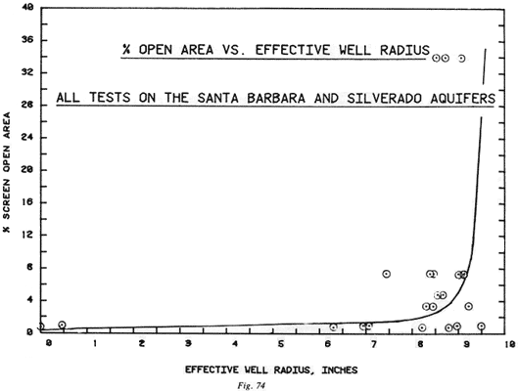
For example, if, as shown on Figure 49, the water level in the well had been 10 ft above the Pressure Transducer reference level instead of 5.46 as was actually measured, the effective well radius would have been about 9.5 inches instead of the 7.44 calculated. Therefore, the larger the effective well radius, the larger the influence the screen/ gravel combination has on well efficiency.
Figure 74 shows a plot of percentage screen open area vs. effective well radius. A hyperbola was fit to the data but, as can be seen in the Figure, little correlation exists. With the exception of the three unstable tests (10, 11, 16) the effective well radius, ranging from 6.3 to 9.5 inches, was fairly independent of the percentage of screen open area.

7.3 Percentage of Screen Open Area, Entrance Velocity, and Well Efficiency
One of the primary objectives of the present investigation was to investigate the effect of screen entrance velocity on well efficiency for various screen open area percentages. As entrance velocity is a component of both frictional head loss and well efficiency, it is important to understand the interrelationships. The concept of well efficiency measures the magnitude of this frictional head loss term related to a percentage of total well drawdown. The theoretical relationship between percentage of screen open area and well efficiency is hyperbolic in form, as shown in Figure 40 (Appendix II). This Figure is a plot of percentage of screen open area vs well efficiency for the Silverado aquifer, with all screens masked to allow a 1/6 circumference of open area.
The correlation analysis shows an unexplained variation of only 35, indicating a high degree of correlation. As can be seen in the Figure, very high efficiencies were attained with relatively low percentage open areas. For example, well efficiencies of 98% and above were achieved with screens having open area percentages of 3% and higher, and entrance velocities up to 2.5 ft/ sec. The significance of these results is apparent in the design of wells where high percentage open areas were thought to be the dominant factor in reducing frictional head losses. In fact, most of the results seen in Figs. 24 through 48 show either directly or indirectly that, above a minimum percentage of open area (3-5%), with entrance velocities less than 2.5 ft/ sec, the results are independent of open area.

8.0 SUMMARY AND CONCLUSIONS
The results from the initial series of tests using the well / aquifer model have proven to be not only encouraging but have provided answers to specific questions relating to basic well design. Most of the objectives as outlined under section 1.2 of this report were met and basic groundwork was laid to satisfy the remainder. Several of the original objectives relating to Peterson’s work could not be achieved due to the nature of initial testing procedures. Realizing these objectives required variation of both model well discharge and screen length during a specific test. In this initial testing, both well discharge and screen length were held constant. Therefore, no data were available to check Peterson’s findings as outlined under objectives 3, 4, and 5 of section 1.2 of this report. However, this area will be covered in subsequent investigations using the well/ aquifer model.
The Santa Barbara and Silverado formations were wise choices of aquifer materials because their different hydrogeologic properties resulted in important test results. This first series of test not only established some basic guidelines and methodology for the testing procedure itself, but has provided insight into important areas for continued research.
Improving techniques developed with each subsequent test were apparent in later test data. Combinations of screens, gravel packs, and aquifers have led to understanding of the importance of the concept of "effective area of opening". The distortion of model aquifer (1/6 of circumference) to model well (1/2 of circumference) was overcome in the later series of tests by selectively masking screen apertures.
The analogy between the model and the theoretical flow equations was verified in every test. Basic theoretical relationships between significant model parameters were also verified using regression and correlation analysis. Thus the correctness of test procedures was confirmed. Specifically, the following conclusions were drawn from results obtained from the initial tests on the Santa Barbara and Silverado aquifers:
- In fine-grained formations such as the Santa Barbara formation, effective area of opening is not the controlling design factor, since frictional head loss was minimal for all screens tested. In these field situations consideration need only be given to sand control, which is a function of screen aperture geometry and pack/ aquifer ratio, and not percentage of screen open area.
- In a properly designed and developed well, entrance velocity is not a factor in controlling production of sand. Velocities of about 9 ft/ sec were achieved in model tests with sand concentrations of less than 1 ppm (see Figure 16).
- Frictional head loss across the screen varies with the square of the entrance velocity in accordance with K = V²/2g. Accordingly, with screen open area percentages above 3-5%, and entrance velocities less than 2.5 ft/ sec, these screen losses were minimal (see Figs. 38 and 39, Appendix II).
- Above a minimum percentage of screen open area (3-5%), and entrance velocities less than 2.5 ft/ sec, well efficiency approaches a maximum and no significant increase in efficiency is achieved with an increase in percentage of open area (see Figure 40, Appendix II).
- The concept of effective well radius is an important indicator of the ability of the screen/ gravel pack combination to increase the permeability immediately surrounding the well screen.
- The concept of effective area of opening is a measure of maximum area of opening available in a well screen, as compared to that area of opening actually available to flow with any particular screen/ gravel/ aquifer combination. Under certain conditions (see Figs. 58, 59, 64, Appendix IV), effective area of opening is so low as to reduce flow rates and increase head losses to the point where a similar well may be uneconomical to operate.
- In many cases the pack/ aquifer ratio and uniformity coefficient are not as important to the construction of an efficient waster well as the actual placement of the gravel pack or development in a natural gravel pack. This suggests that the controlled conditions regarding gravel pack placement in the model were more important than a lower pack/ aquifer ratio. However, as was noted in three tests (10, 11, 16), this last observation may not hold true with low area of opening screens (<1%) with improperly selected gravel packs.

9.0 ACKNOWLEDGEMENTS
This research was made possible through the efforts and resources of Roscoe Moss Company of Los Angeles and all their personnel, whose tireless dedication and devotion to this project has made it a success.
Special thanks goes to Dave Walker, whose ingenuity and resourcefulness overcame many of the problems encountered during model development, and to Dr. John List of the California Institute of Technology, who provided helpful guidance during the course of the investigation.
Finally, sincere appreciation is given to George Moss and Roscoe Moss, Jr., without whose guidance and support this project would never have begun.

Appendix I

Summary of Background Research

BACKGROUND LITERATURE RESEARCH
The relationship between well yield and transmitting capacity through well screens has been studied since the early 1900’s. These studies include both theoretical and experimental aspects and many theories have been developed. The following represents a summary of findings of the principle investigators in the field of well/ aquifer interrelationships, and the applications to present the study.
- Lehr, G.J. Brunnenwiderstande, Iherberechnung, entatehung und besietigung. Gesundheits; Ingenieur, 49: 749-52, December 4, 1926.
Major Findings: In 1926, G.J. Lehr pointed out that head loss through a well screen consisted of two distinct and separate parts - (h₂) Loss of head that takes place through the screen openings due mainly to their size and shape, and (h₁). The component of head loss attributed to the turbulence of water moving upward axially in the well screen. The sum of these two losses represents the total frictional head loss required to bring the water from outside the well screen to the pump intake. Quantitatively, Lehr expressed these two losses as

where:
h₁ = loss of head in pipe (ft)
V₁ = velocity of flow in pipe (ft/ sec)
V = velocity of water entering perforations (ft/ sec)
V₂ = velocity of water at perforation exit (ft/ sec)
h₂ = loss of head through perforations (ft)
C₁ = pipe roughness coefficient
C₂ = screen roughness coefficient
g = gravitational constant
Application to the Present Study: Lehr’s analysis minimized the component of head loss through the screen compared to the head loss in the pipe. However, this may not hold true in all well/ screen situations. One of the objectives of the well / aquifer model will be to disprove or corroborate Lehr’s theories.
- White, H.L. Gravel Packed Wells. American Water Works Journal, 29; 475-83, April 1937
Major Findings: In 1937, White stated that the size of the gravel in the gravel filter should be based on the size of the sand in the formation. Also, size of the screen openings should be as large as possible without allowing gravel to pass through them. White summarized his findings for the gravel pack as: 1. Size should be a function of sand size. 2. Spherical shapes are ideal. 3. Hard granite-like material should be used. 4. Gravel should be clean, well washed, and of uniform size.
Application to the Present Study: White’s conclusions are fairly general except possibly his statement on necessity of uniform size. One model objective will be to test the effect of gravel pack uniformity and the relationship of fine sand infiltration with different aquifer materials.

- Muskat, J. Flow of Homogeneous Liquids through Porous Media. New York, Mcgraw-Hill Book Co., 1937.
Major Findings: Muskat in 1937 made a statement that production capacity of a well is very sensitive to the permeability (hydraulic conductivity) of the zone immediately surrounding the well bore. If the annular zone adjacent to the well bore has a hydraulic conductivity greater than that of the adjacent aquifer, then the production rate of the well will be greater than the same well without any gravel filter. However, Muskat pointed out that these effects do not increase linearly in proportion to the radius of the zone of greater permeability.
Application to the Present Study: Muskat’s remarks are very important and form one of the principle objectives of the present study (i.e., the character and thickness of the gravel filter).

- Bennison, E.W., and others. Useful Life of Water Wells. American Water Works Association Journal, 39: 32-40, January 1947.
Major Findings: Bennison made some fairly general comments regarding well screens. His work can be summarized in five major points: 1. Well screen is not a strainer to hold out all the formation, but rather acts as a stabilizing device to support the water-bearing formation during development and subsequent pumping. 2. Screen openings should be as large as possible, but also sized on intelligent interpretation of mechanical grading analysis and local ground conditions. 3. The well screen should have as many openings and as few blank areas as possible so as not to shut off water-bearing formation. 4. Smaller particles migrate between larger particles, and because of this there will be a reduction in the total volume of open space. 5. Uniformity of grading of the mixture is more important from a water-yielding standpoint than the size of the particles themselves.
Application to the Present Study: Bennison’s comments are quite general, and form more of a qualitative statement of well known conditions rather than providing quantitative values. However, Bennison does point out the importance of uniformity in the gravel pack, which will be investigated.
- Santini, S. Consideraciones Sobre Las Filtras que se Utilizan en Los Distentos Pozos Semisurgentes. Boletin de Obras Santarias de la Nacion, 6: 279-91, March 1942.
Major Findings: Santini defined a coefficient of capacity (C_{s}) of a well screen as the area of slot openings divided by the total area of the outside surface of the well screen. This coefficient, when multiplied by the effective porosity of the aquifer, gives a new porosity of the aquifer. Consequently, a higher coefficient screen would be more desirable than a screen with a lower coefficient.
Application to the Present Study: Santini’s findings regarding the fact that the total percentage of open area should be as high as possible will be investigated. However, Santini neglected to mention other important design factors such as strength and sand control.

- U.S. Corps of Engineers. U.S. Waterways Experimental Station Field and Laboratory Investigation of Design Criteria for Drainage Wells, Vicksburg, Mississippi, 1942. (Technical memorandum Number 195-1).
Major Findings: The Corps of Engineers in 1942 was concerned with the construction of drainage wells along the Mississippi River levees. They undertook an investigation, including field and laboratory analysis, to determine proper well design. Their efforts concentrated on four major types: 1. Brass well screens. 2. Non-metallic perforated pipes with filters. 3. Porous concrete drain pipes 4. Gravel-filled relief wells.
Testing consisted of determining the discharge efficiency of the various well types. Results established a criterion which was then used to design the wells:
where size represents the percentage passing through the screen openings.
Another conclusion resulting from field and laboratory tests was that there was little difference in discharge efficiency applying different gravel pack combinations to brass screens having the same length, diameter, and perforation geometry. Results from the tests on gravel-filled relief wells indicated that these wells have a very low discharge efficiency due to frictional resistance created by water flowing upward through the gravel. The investigators also pointed out that the effect of friction and the resulting velocity head losses in the riser and discharge pipes were an important factor in reducing discharge efficiency.
Application to the Present Study: The Corps’ statement regarding the pack / aquifer ratio will be reviewed since pack/ aquifer ratios are an important objective of the present study.
- City of Elizabeth, North Carolina. Shallow Wells tapped Dismal Swamp for City Water Supply. Engineering News Record, 133; 644-6 November 16, 1944.
Major Findings: the City of Elizabeth, North Carolina, undertook a study in 1944 to determine the most effective design of production wells. Major problems were occurring with well operations due to entrance of fine sand into the distribution system, as well as clogging of well screens. Experiments were undertaken with several types of gravel packs and screens. Their major conclusion was that the best type of screen was a slotted screen number 20 (.020 inches), combined with a gravel pack size ranging from 1/16 to 1/8 inch in diameter.
Application to the Present Study: Study results may have been optimum for the particular aquifer conditions near Elizabeth, North Carolina, but the findings do not hold for all different wells, aquifer conditions, and materials.

- Bennison, E.W. Groundwater, Edward E. Johnson, St. Paul, Minnesota, 1947.
Major Findings: One of the most influential statements regarding flow of water into well screens can be found in Bennison’s book in the chapter, "Hydraulics of Wells". The following is a direct quotation from that chapter: "Our opinion is sufficient open area should be provided to keep the entrance velocity down to 0.10 to 0.25 feet per second. A conservative figure would be 0.10 ft. per sec. After allowance was made for the portion of the open area that would be blocked off by formation particles."
Bennison failed to state, however, what major experimental or theoretical work was ever done to back up his statement of entrance velocity. Unfortunately, many important reference books still blindly use his work by quoting the figure of 0.10 ft/ sec as the maximum entrance velocity.
Application to the Present Study: Bennison’s statement regarding entrance velocity is one of the major objectives of the present well / aquifer model study - not particularly to prove or disprove his numbers, but to objectively establish criteria between optimum well design and entrance velocity. A very rigid statement such as Bennison’s cannot be applied to every aquifer/ well combination.
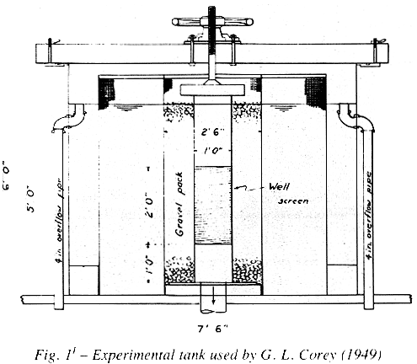
- Corey, G.L. Hydraulic Properties of Well Screens; Master of Science Thesis, Colorado Agriculture and Mechanical College, Fort Collins, Colorado, 1949.
Major Findings: Corey built an experimental tank consisting of a 2 ft section of well screen surrounded by a 2 ½ ft gravel envelope encased in a 6 ft circular tank (see Figure 1¹). The well screen was 12 inches in diameter. With this apparatus, Corey measured entrance losses through different screen/ gravel combinations. Several major conclusions resulted from his investigations: 1. The screen must be made of a noncorrosive material if the well is to have a long life. 2. The screen must be sufficiently strong to prevent collapse. 3. Cost of the screen must be acceptable. 4. Screen openings and gravel pack must be such that the well will not pump sand.
Corey made a significant contribution with his statement that above a certain perforated open area (approximately 15%) head losses through well screen are minimal for a constant discharge (see Figure 2¹).
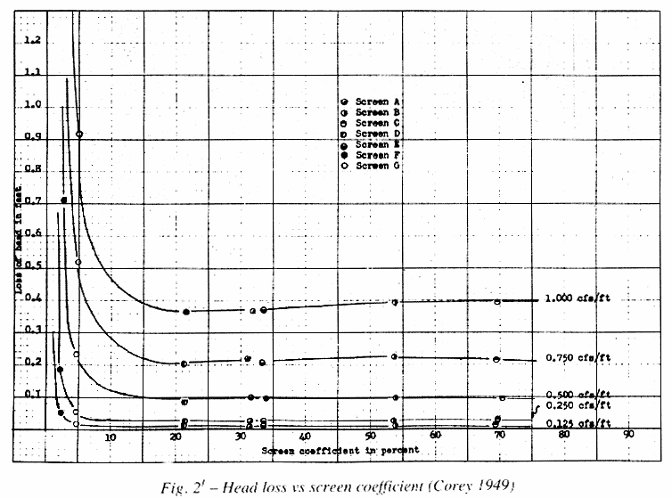
Application to the Present Study: Corey’s findings are quite significant, and he was one of the first to mention the importance of structural strength of a screen as an important design factor. Corey also made a very important point regarding a limiting percentage of screen open area. This will be carefully examined with the model.

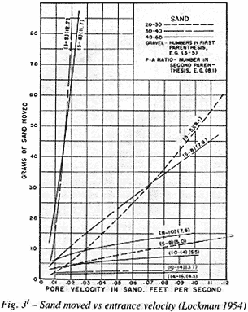
- Lockman, J.R., Rohwer, C. Selection of Gravel Pack for Water Wells in Fine, Uniform Unconsolidated Aquifers. Unpublished Progress Report - Irrigation and Drainage investigation of the Agriculture research Service, Fort Collins, Colorado, 1954.
Major Findings: Lockman ran a series of tests on uniform aquifers and gravel packs at Colorado State University. His model consisted of a 6 in. plastic tube fitted with screens to hold the pack and aquifer materials. The discharge amount of sand moving through the screen, and head readings along the flow paths were measured. Criteria were established for various pack/ aquifer combinations based on piezometric head changes in the model and the amount of aquifer that moved into the gravel pack during the test. Results from Lockman’s investigations indicated that the amount of aquifer material moving into the gravel pack varied directly with velocity of water through the aquifer pores, aquifer hydraulic gradient, and pack/ aquifer ratio. He also found that, at low pack/ aquifer ratios, very little sand movement occurred, regardless of entrance velocities. Pack/ aquifer ratios of 11 to 12 showed sand movement increasing rapidly with increasing velocity. Pack/ aquifer ratios of 5 and below demonstrated that, regardless of pore velocity, little or no sand movement occurred (see Figure 3¹).
Application to the Present Study: Lockman’s results are very significant to the present investigation since they corroborate the theory that pack/ aquifer ratio is more important in stabilizing aquifer materials than limiting entrance velocity.
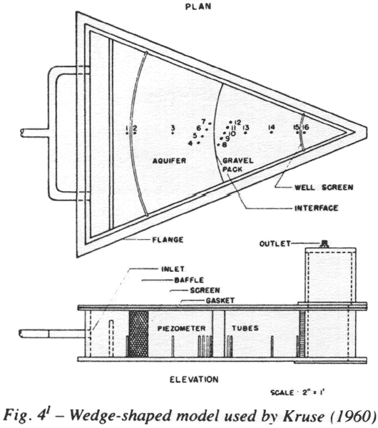
- Halderman, A.D. Design of Gravel for Water Wells in Fine Unconsolidated Aquifers, Unpublished Master’s Thesis, Colorado State University, 1955.
Major Findings: The most significant result of Halderman’s work was with regard to the study of the uniformity coefficient of gravel. Uniformity coefficient is defined as the ratio of the 60% passing size to the 10% passing size of the material. Halderman stated that a material with a higher uniformity coefficient would have smaller interstices than one with a lower uniformity coefficient. Since size of the interstices controls sand movement, a graded material could be expected to form a more effective sand filter than a uniform material. Halderman also corroborated Lockman’s results regarding pack/ aquifer relationships and found that a pack/ aquifer ratio of 8 bordered on instability for uniform materials.
Application to the Present Study: Halderman contradicts many previous investigators with his statement that a well graded gravel pack would form a more effective sand filter. This is significant and will be investigated in this study.

- Kruse, G. Selection of Gravel Packs for Wells in Unconsolidated Aquifiers, Technical Bulletin No. 66, Colorado State University, March 1960.
Major Findings: Kruse studied the problem of well design using a 45º wedge-shaped plexiglass model (see Figure 4¹). The model was 6 in. high, with a 30 in. radius. The tip of the wedge represented the center of a 12 in. screened irrigation well, surrounded by a 9 in. gravel pack. Kruse used continuous slot well screen with 0.040-inch openings. A 16 ft. head was imposed on the model and pressure distribution measured using 16 piezometers. Discharges were quite small, ranging from ½ to 6 gpm. Kruse found that when uniform gravel packs were used with uniform aquifers, 9.5 was found to be the maximum stable pack/aquifer ratio. For pack/aquifer ratios between 4 and 12, sand movement increased in proportion to the pack/aquifer ratio. At pack/ aquifer ratios of 15, a definite failure occurred and at pack/aquifer ratios of 20 to 25, a continuous movement of the aquifer could be detected visually. A large channel was eroded through the aquifer before the first 30 minutes of the test had ended.
Kruse’s main conclusions can be summarized in the following points: 1. Less aquifer movement occurs with a non-uniform pack than with a uniform gravel pack at the same pack/aquifer ratio. Uniform gravel packs are those having uniformity coefficients from 1.3 to 2 and non-uniform gravel packs have uniformity coefficients from 3 to 5. 2. At low pack/aquifer ratios, increasing the uniformity coefficient increases the initial sand movement. 3. At high pack/aquifer ratios, increasing the aquifer uniformity coefficient decreases the sand movement. 4. Surging reduces the head loss at the interface significantly.
Application tot he Present Study: Kruse's results are very significant in that they point out a relationship between pack/aquifer ratio and uniformity coefficient. These factors seem to play an important part in aquifer stabilization and will be tested in the model.
- Terzhghi, K., and Peck, R.B. Soil Mechanics in Engineering Practice, New York, John Wiley and Sons, 1948.
Major Findings: A filter to control seepage under dams was patented by Terzhghi in 1921. His filter criteria were as follows:

Application to the Present Study: Terzhghi’s criteria are similar to the Corps of Engineers criteria established as a result of the Mississippi levee study (1942). His work represents another independent study on the importance of pack/aquifer ratios to aquifer stability.
- Bertram, G. E. An Experimental investigation of Protective Filters, Soil Mechanics, Series No. 7, Graduate School of Engineering, Harvard University, 1940.
Major Findings: Bertram ran a series of tests on samples of Ottawa sand and crushed quartz. He concluded that for materials of 50% compaction, as defined by Terhghi, the following results were valid: 1. Terzhghi’s criteria were sound and provide a reasonable margin of safety. 2. Critical pack/ aquifer ratios are practically independent of grain shape. 3. Critical pack/ aquifer ratios are fairly constant for hydraulic gradients ranging from 6 to 20 (the range investigated).
Application to the Present Study: Bertram’s findings (especially Item 3) will be examined in the present study.
- Karpov, K.P. The Use of Laboratory Tests to Develop Design Criteria for Protective Filters; A.S.T.M. Proceedings, Volume 55, 1955.
Major Findings: Karpov developed tests on uniform graded filters and concluded that the ratios ranging from 5 to 10 were found to be satisfactory for uniform materials. Karpov also recommended that the particle size distribution curve of the filter should be approximately parallel to that of the base (aquifer). His statement regarding the gravel pack curve paralleling the aquifer curve is interesting and contradicts Halderman and Lockwood’s work.
Application to the Present Study: Karpov's work regarding pack/ aquifer ratios will be tested.

- Zangar, C.N. theory and Problems of Water Percolation; Engineering Monograph No. 8, U.S.D.I., Bureau of Reclamation, Denver, Colorado, 1953.
Major Findings: Zangar found, using electrical analog models, that the effect of a well screen on a partially penetrating well under laminar flow conditions would reduce the effective diameter of a well according to the ratio of the area of perforations to the total cylinder wall area.
Application to the Present Study: Zangar's work is mainly theoretical and will be studied in the theoretical analysis of results.

- Vaadia, Y., and Scott, V.H., Hydraulic Properties of Perforated Well Casings; Proceedings of the A.S.C.E. Irrigation and Drainage Division Paper, 1505, 1958.
Major Findings: Vaadia and Scott did some theoretical work on different types of well screens. Their conclusions stated that, for a given length and screen diameter, open area was a major factor in head loss. However, for gravel packed wells, head loss decreased with increased uniformity, roundness, and grain size of pack material. They devised a procedure for estimating head loss based on screen diameter, slot size, and patterns of screen commonly used in California.
Application to the Present Study: Their statement that open area is a major factor in well head loss and decreasing head loss is a function of uniformity will be examined by use of the model.
- Wen, H.L., Interaction Between Well and Aquifer; A.S.C.E. Proceedings No. 578, 1954.
Major Findings: Wen performed a theoretical analysis of head loss across well screen sections, arriving at three main conclusions. 1. Formation loss is divided into two main components: a) One is similar to the velocity head in the well near the discharging end; b) The other is roughly equal to that obtained when the assumption of uniform piezometric head is assumed along the surface of the well screen and casing. 2. Velocity distribution in the aquifer obtained by assuming a uniform piezometric head along the well is accurate for practical purposes. 3. Loss of head through the well screen is usually negligible, and what is usually considered to be well screen loss is actually loss caused by the variation in piezometric head along the well.
Application to the Present Study: Wen's work is significant. He states that loss through the well screen is negligible, compared to loss caused by variation in piezometric head along the well. One of the objectives of the present model investigation will be to try and define the head loss components and their magnitudes.

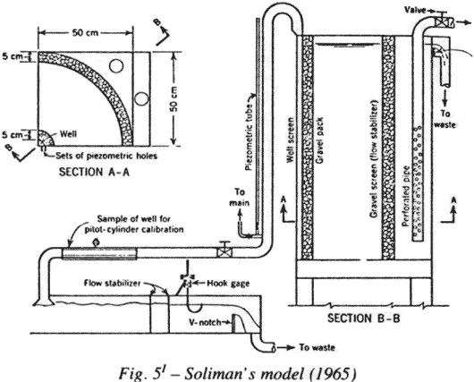
- Soliman, M.M., Boundary Flow Consideration in the Design of Wells; Journal of the Irrigation and Drainage Division; Proceedings of the American Society of Civil Engineers; March 1965, IR 1.
Major Findings: Soliman performed a laboratory and theoretical investigation of a well system. In his model (see Figure 5¹), a 50 cm by 50 cm tank held a 90° section of an aquifer. His main conclusion regarding well screen design stated that most water enters near the discharging end of the screen. Maximum entrance velocity cannot be greater than the safe value above which cavities will be built up on the screen openings in the zone. He applied entrance velocities thirty times greater than Bennison's 0.1 ft / sec without any harm to the well material. Soliman proposed that, once maximum velocity is known, the maximum length of screen can be calculated. This maximum screen length need only be equal to 40% of the maximum saturated thickness of the well, and the additional screen length can be eliminated or substituted by a gravel medium having more than 200 times the aquifer hydraulic conductivity.
Application to the Present Study: The most significant finding in Soliman's work is that entrance velocities of 3.0 ft/ sec (30 times Bennison's proposed upper limit) were used without any undesirable effects. This clearly suggests that entrance velocity alone is not the critical design factor. However, Soliman's statement regarding elimination of the lower 60% of the aquifer material and replacing it with highly conductive gravel seems incomplete, in that he does not consider the effect of increased head loss due to partial penetration effects, as well as head loss due to vertical movement of water upward through the gravel pack.
- transactions, American Society of Civil Engineers; Paper 2755, Volume 120, 1955.
Major Findings: The authors developed theoretical relationships based on continuity, momentum, and energy equations. Assuming that viscous forces are much smaller than inertial forces, the Reynolds number is not significant. They also assume that drag in the well screen is almost entirely the result of the influence of the jets of water issuing from the screen openings, and that the roughness coefficient of screen itself can be neglected. Based on these assumptions, they proceed to derive their basic relationship involving the loss coefficient, which is defined as the head loss across the screen:
where
= loss coefficient
h_{pz} = difference in piezometric head between the inside and outside of
the screen
C = 11.31 Ap Cs
Ap = Percent open area of screen
A = Cross sectional area of screen
Cs = Screen coefficient
L = Length of screen
D = Diameter of screen
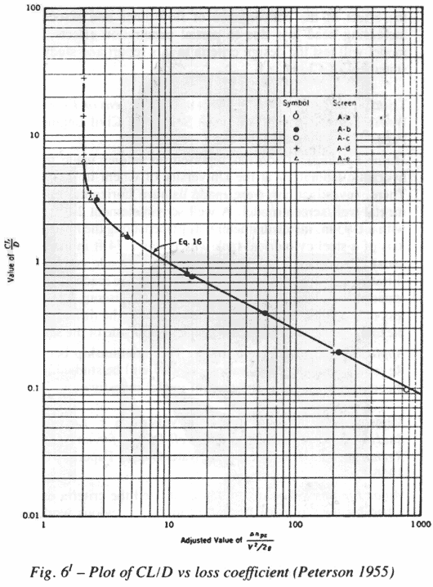
The screen coefficient Cs is obtained from the plot of CL/D versus the loss coefficient. This plot also shows that for CL/D values greater than 6, the loss coefficient asymptotically approaches a minimum value of 2 (see Figure 6¹). The reason for this is obvious: When CL/D increases, the value of 1 compared to the value of the hyperbolic cosine term becomes insignificant.
Their test apparatus consisted of a circular tank 6 ft high and 7.5 ft in diameter (see Figure 7¹). The 12 in. well screen is surrounded by a 2.5 ft gravel pack. The remaining area is surrounded by water. Discharge through their model ranged from 56 gallons per minute to almost 900 gallons per minute.
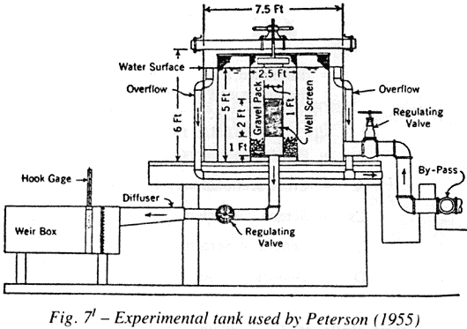
Their main conclusions are summarized as follows: 1. CL/D must be greater than 6 for minimum well screen loss. 2. If CL/D>6, loss through the well screen is independent of gravel size, and therefore the pack can be selected on the basis of sand control. 3. When CL/D>6, actual head loss for a given discharge depends only on the diameter of the screen. An increase in the diameter may reduce the value of CL/D below 6 and in this case the loss will no longer be a minimum. When this occurs, CL/D can be increased by using a longer screen. 4. The greater part of the flow in a well takes place over the length of the screen, measured from the discharging end of the well, that is required to obtain a value of CL/D = 6. The quality of this section of screen is therefore of greater importance than that of the remainder of the screen.
Application to the Present Study: The authors have done a significant amount of work in testing well screens. However, many comments regarding this paper point out that the authors' results are a function of the geometry of their particular model and the materials used in the testing. Also, the author ignored the effect of the convergence of flow lines and associated increasing head loss due to partial penetration effects. The model will test the design criteria in this report and study the statement of CL/D>6.
- Tison, G. Discussion of the Effect of Well Screens on Flow into Wells; Transactions of American Society of Civil Engineers; Paper 2755, Volume 120, 1955.
Major Findings: Tison has reported on studies made in the hydraulic laboratory at the University of Ghent in Belgium. There, investigations were made using a horizontal experimental well/ screen model. A well screen element 2.6 ft long with a 1.93 in. inside diameter was placed along the horizontal axis of a steel cylindrical tank which was 2.74 ft in diameter and 3.81 ft long. Investigations were then made concerning filtration velocity and several conclusions were reached. Tison stated that if the Reynolds number (inertial/ viscous forces) is less than 5, then discharge is proportional to the difference of piezometric head between the inside and outside of the screen.
Application to the Present Study: This relationship between Reynolds number and filtration velocity will be studied in the theoretical analysis of the present model investigation.
- Johnson, A.I., Maston, R.P., and Versaw, S.F. Laboratory Study of Aquifer Properties and Well Design for an Artificial Recharge Site; U.S. Geological Water Supply Paper, 1615-H, 1966.
Major Findings: the investigators utilized the criteria established by the Corps of Engineers in their previous work on pack/ aquifer ratios:
4 (for max stability)
4 (for max permeability)
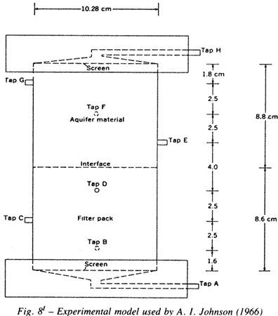
A permeameter cylinder (see Figure 8¹) was built measuring 10.3 centimetersin diameter and 17 centimeters high. Screen material was placed on the bottom of the cylinder. Overlying the screen were 8.6 centimeters of filter pack and 8.8 centimeters of aquifer material. Laboratory tests showed that an improperly designed filter pack could result in plugging by fine particles penetrating from the aquifer. However, it appears that the greatest permeability decrease might be caused by compaction of the filter pack as a direct result of surging action from well development procedures or alternating recharge/ pumping cycles.
Application to the Present Study: The results of this paper point out the importance of proper pack/ aquifer ratios as well as development procedures. These will be studied in detail.
- Johnson, E.E. Judging Proper Gravel Pack Thickness; Johnson National Drillers Journal, Volume 27, 1955. Sand Studies Can Improve Well Design; Johnson Drillers Journal, Volume 34, 1962, Basic Principles of Water Well Design; Johnson Drillers Journal, Volume 35, 1963.
Major Findings: These articles state that, for artificially paced gravel filters, a properly graded sand and gravel pack, combined with a screen slot size which retains most of it, will insure that the well will not pump sand. The author point out that removal of fine sand or silt from the adjacent aquifer material through the well screen openings can be accomplished by surging and bailing. Proper engineering of a carefully sized and placed gravel pack is therefore emphasized. Johnson pointed out that the filter pack need only be a fraction of an inch thick to successfully retain aquifer particles. However, a thin pack is very difficult to place in the field, and therefore a thicker one is necessary in practical applications.
Application to the Present Study: Johnson's statement is quite general regarding pack/ aquifer ratios and does not propose any original relationships. The statement on minimum thickness of a gravel pack, however, is interesting and will be tested.

- Kupay, M.T. Head Loss Measurement Through a Perforated Casing; Unpublished report; University of California at Davis; Spring 1957.
Major Findings: Theoretical and experimental procedures were undertaken with the object of studying the efficiency and performance of various types of perforated casings. The experimental procedure was similar to that used by Vaadia with some modifications. Kupay's main conclusion corroborated the Vaadia- Scott research.
Application to the Present Study:These results will be used in checking the experimental results against the theoretical analysis of flow of water into wells.
- Carlson, J., U.S. Bureau of Reclamation. Personal Communications; Denver, Colorado, June 1978.
Major Findings: Carlson is currently using a model that simulates a well / aquifer system. The model was built by the U.S. Bureau of Reclamation's hydraulic laboratory center at Denver, Colorado. It consists of a 6 ft diameter vertical pipe 16 ft high, filled with sand. A continuous slotted 12 in. well screen is placed concentrically in the center. Surrounding the well/ aquifer pipes is an 8 ft square tank filled with water to provide the necessary flow. Tests are now under way using this model to try to determine the relationship between head loss and entrance velocity into wells.
Application to the Present Study: Some instrumentation techniques used in Carlson's model(mainly the use of a continuous computer data logging Scanivalve system) will be applied to the present model.

- Williams, D.E. Complimentary Investigations of a Ground Water Development in the Gorgan Plain Area of Iran; Limited Distribution; Report Submitted to the Ministry of Energy, Department of Ground Water Affairs, Government of Iran; Payab-Louis Berger Consulting Engineers; 1973.
Major Findings: Experimental research was undertaken by Agro-Water Consulting Engineers, in cooperation with Irab Engineering drilling company, to develop sand-free wells in areas along the Caspian Sea coast in northeastern Iran. In this area, the problem of fine sand production had not been consistently overcome, using conventional concentrical well screen and gravel pack design methods. Artesian pressures exceeding 2 atmospheres made installation and completion difficult. To combat this problem with commercially available horizontal louver shutter screen, a two-stage gravel pack was conceived. This design consists of an expanded metal mesh, 17 inches in diameter, placed around a 12 in.screen. The annular space is filled with a well graded gravel pack. The pre-packed screens are centered in the well bore (22 in. diameter), and the annular space filled with a graded gravel pack using conventional washdown or tremie pipe methods. Careful development of these wells produced sand-free water with high discharges and low drawdowns. This pre-packed design has been successfully used for the past seven years in Iran and has proven that sand-free water can be produced from fine-grain aquifers with high entrance velocities if proper pack/ aquifer ratios are maintained.
Application to the Present Study: The results from these works will be tested in the model and the effect of pre-packed screens versus non-prepacked studied.

APPENDIX II

Summary of the Initial 25 Tests on the Santa Barbara and Silverado Aquifers

Results of Regression and Correlation Analysis (Figs 17-23)
on the Five Significant Variables (Q, Ap, h, E, V)
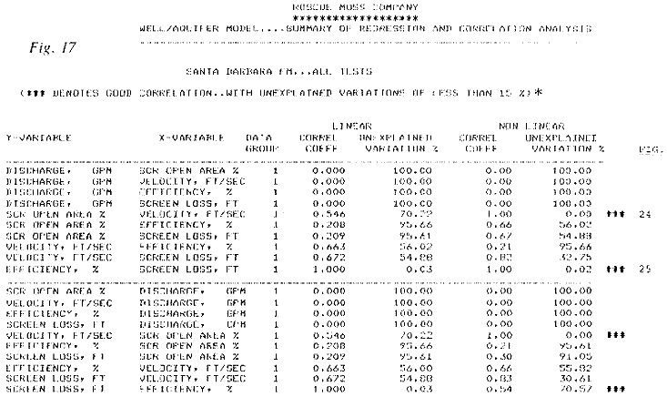
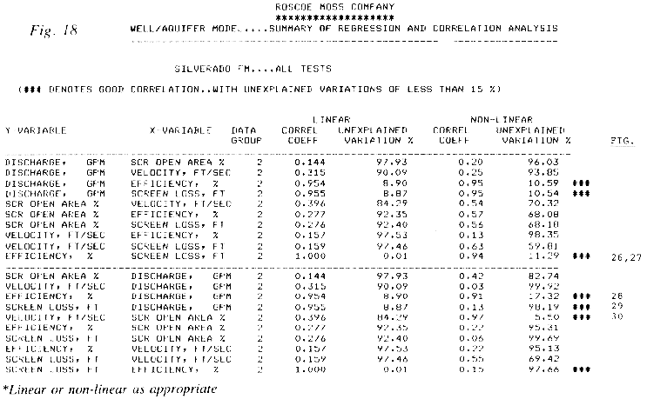

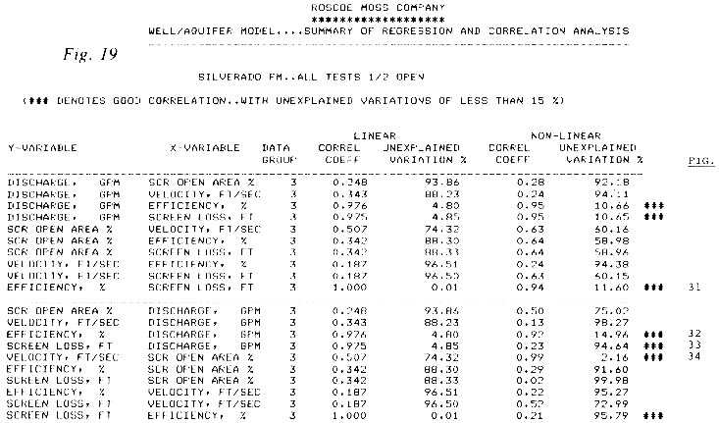

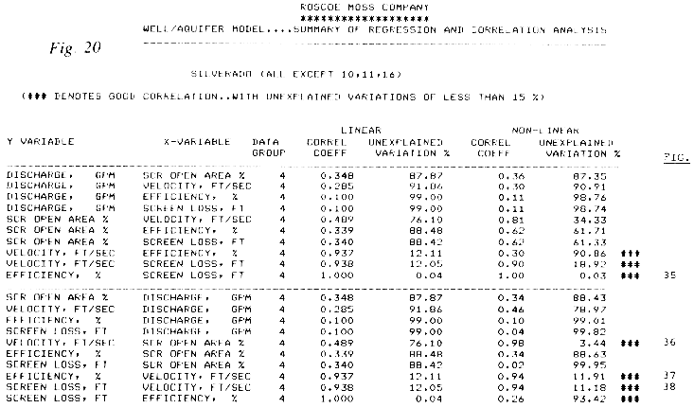

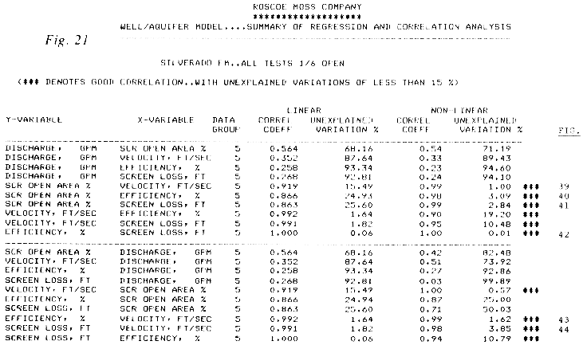

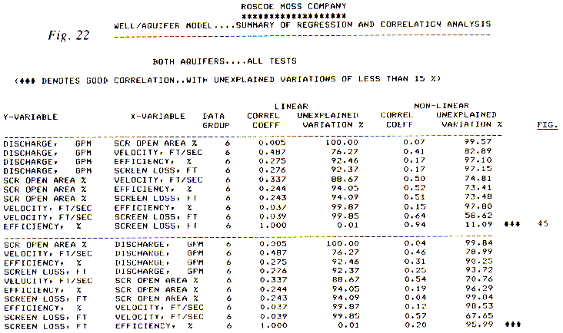

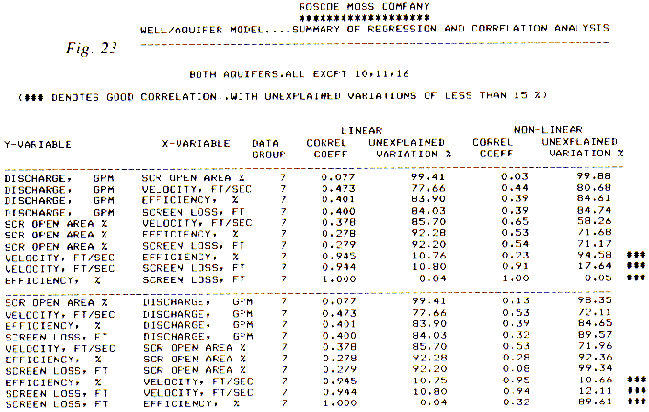

Graphical Plots of Regression and Correlation Analyses (Figs 24-48)

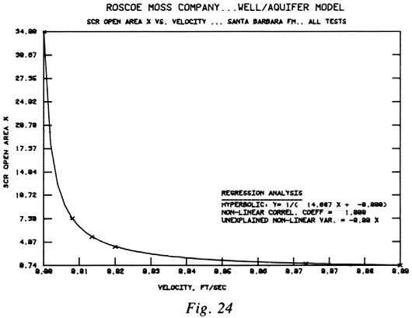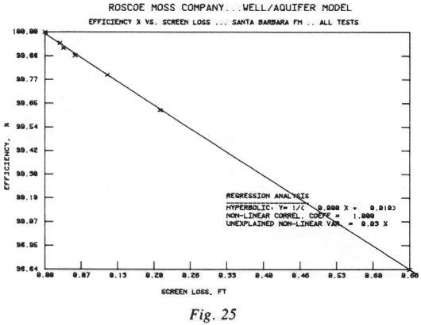

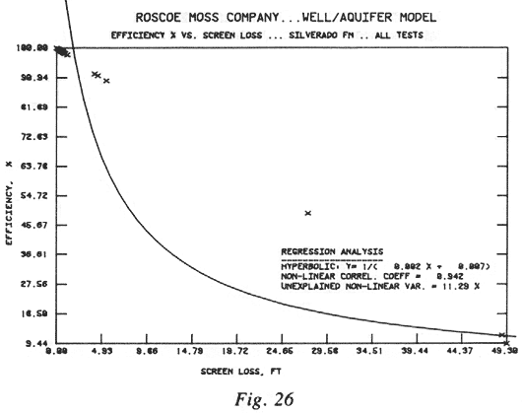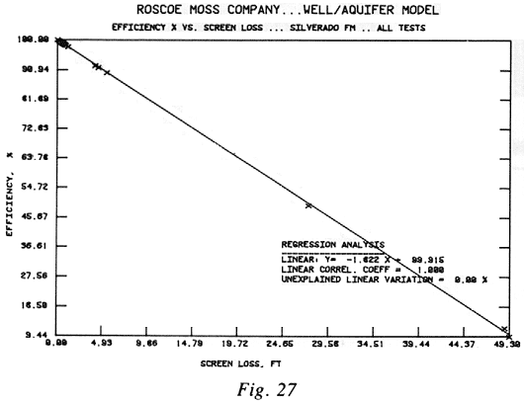

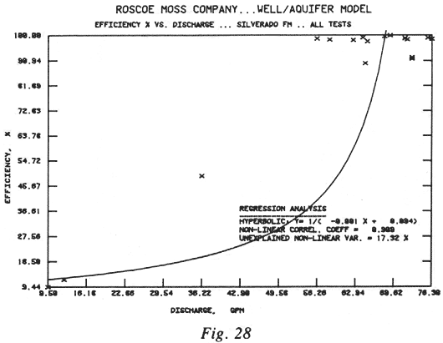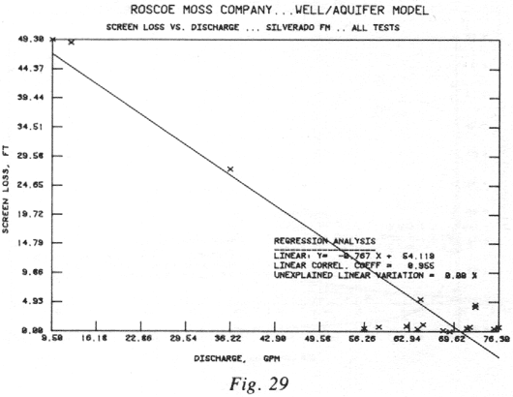

Graphical Plots of Regression and Correlation Analyses (Figs 24-48) – cont’d

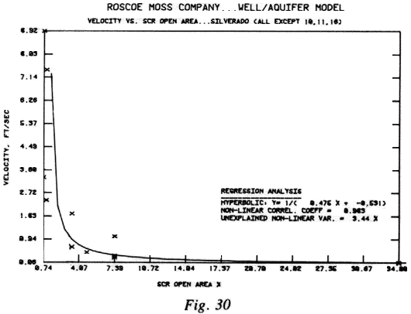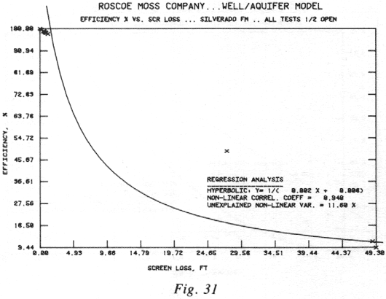

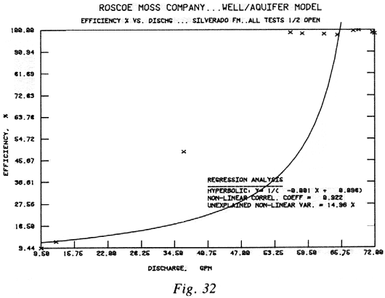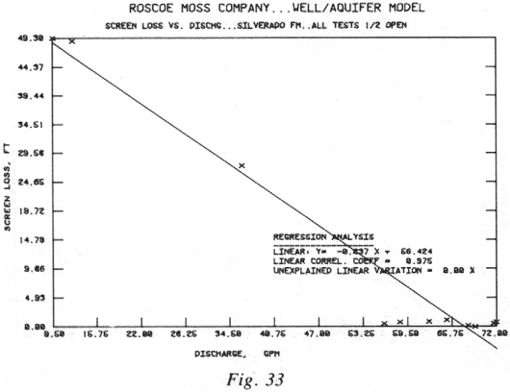

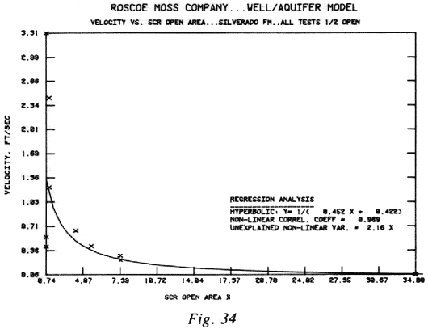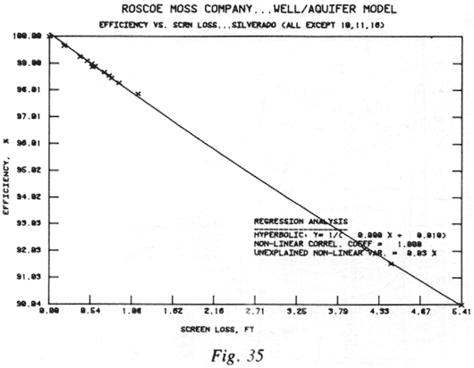

Graphical Plots of Regression and Correlation Analyses (Figs 24-48) – cont’d

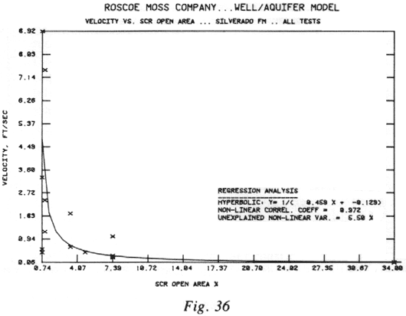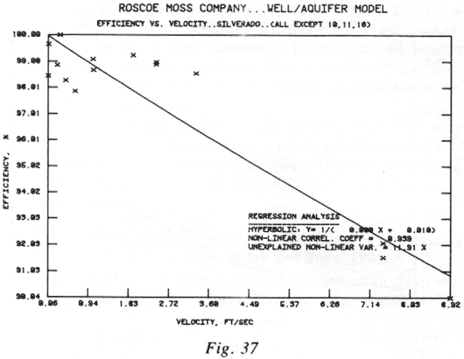

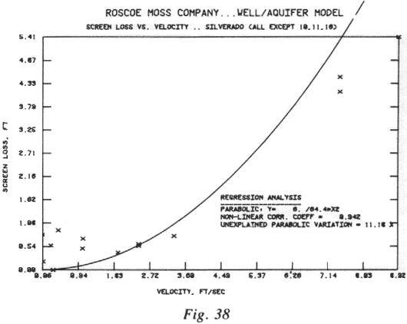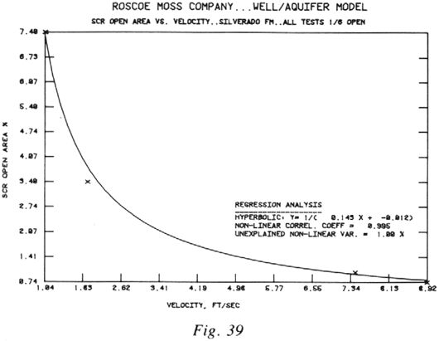

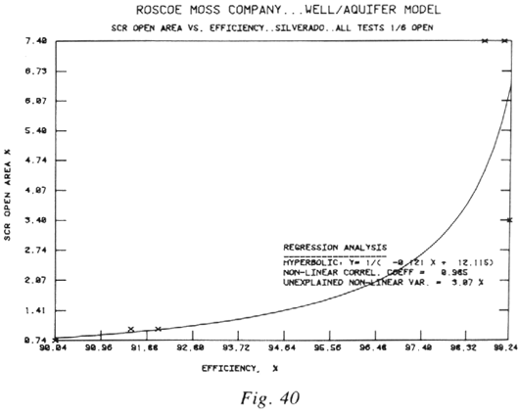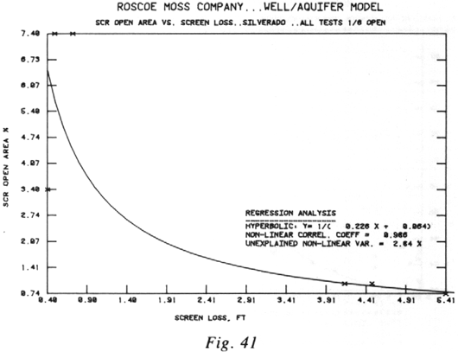

Graphical Plots of Regression and Correlation Analyses (Figs 24-48) – cont’d

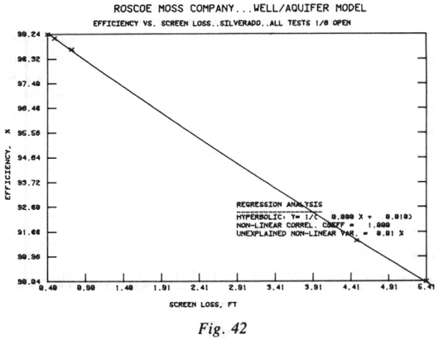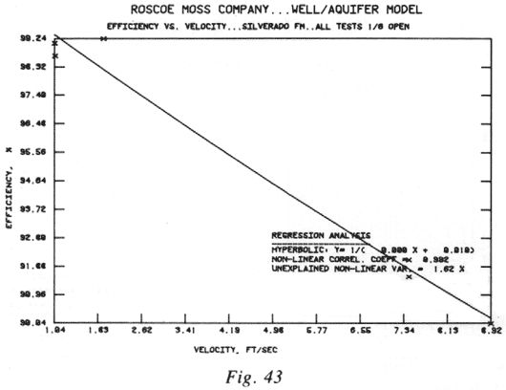

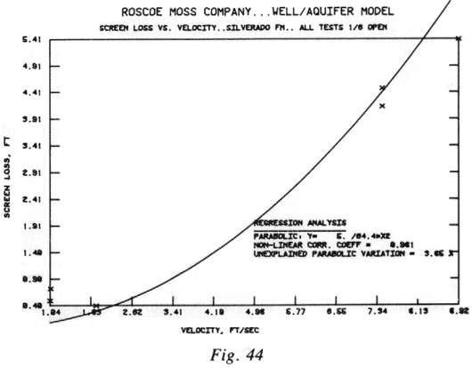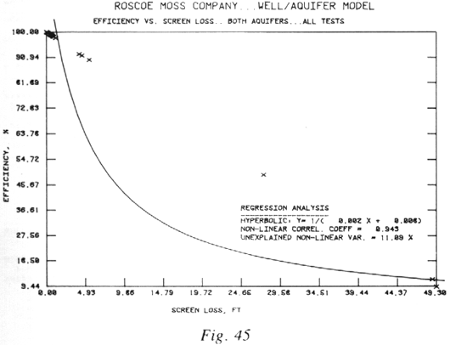

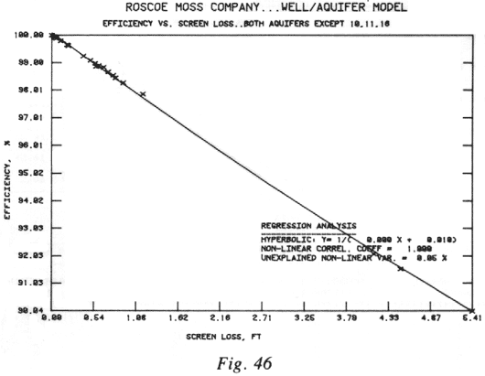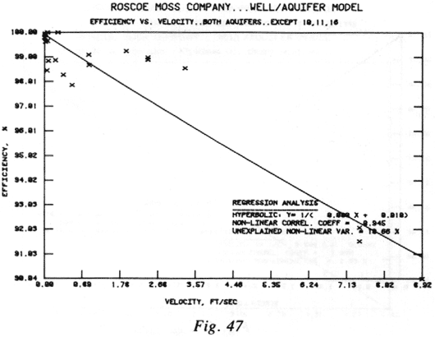

Graphical Plots of Regression and Correlation Analyses (Figs 24-48) – cont’d

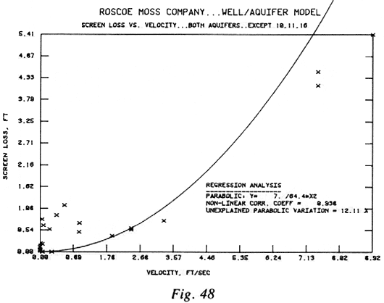

APPENDIX III

Basic Model Test Data from the First 25 Tests
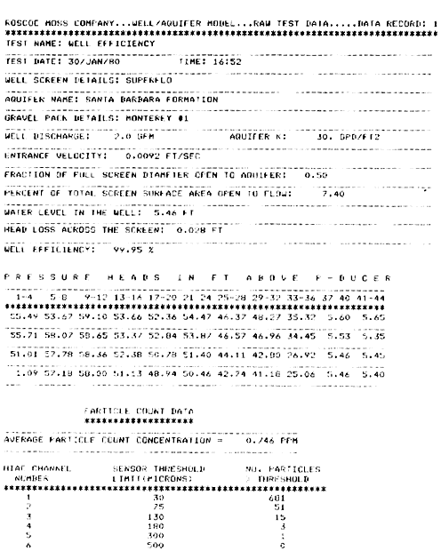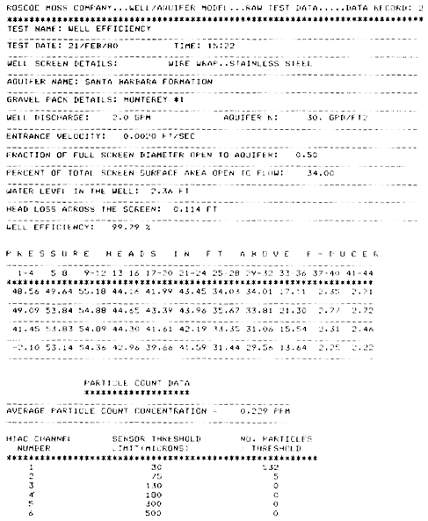

Basic Model Test Data from the First 25 Tests – cont’d

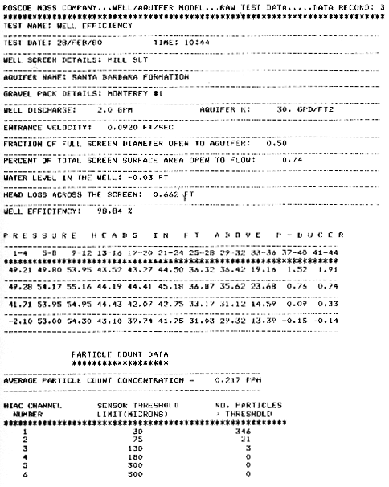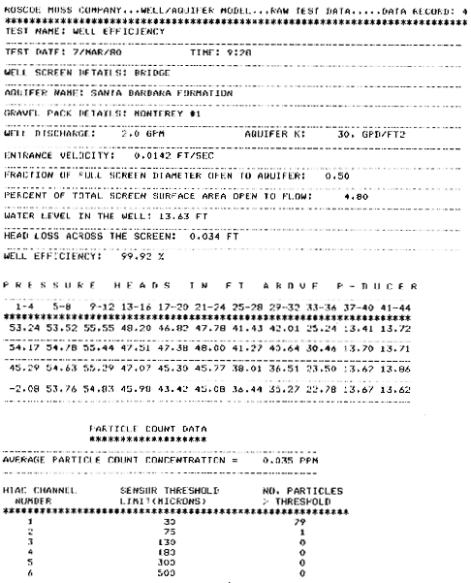

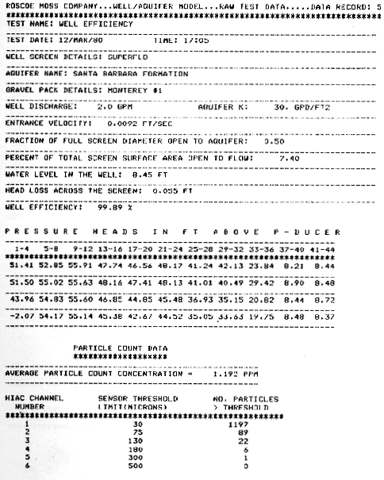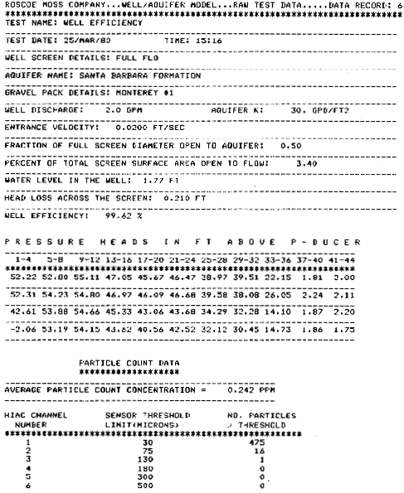

Basic Model Test Data from the First 25 Tests – cont’d

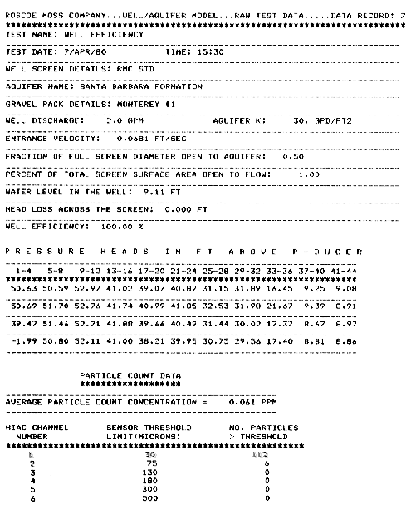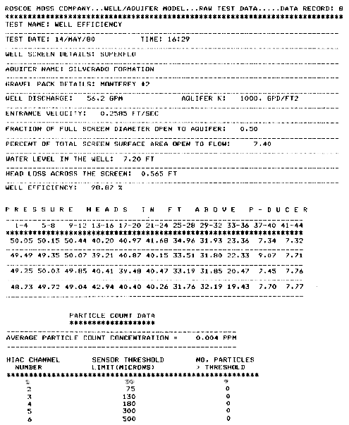

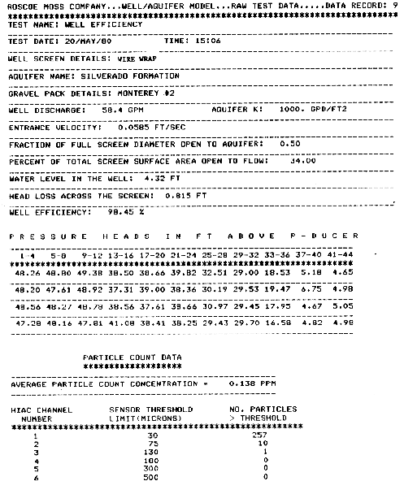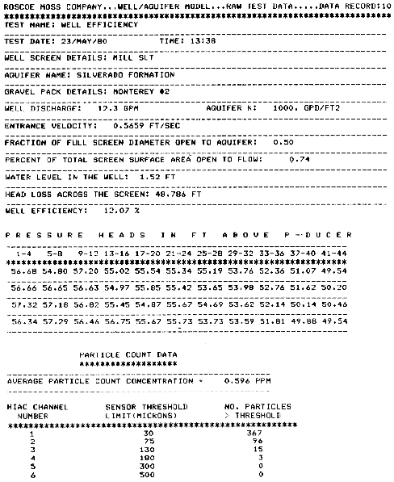

Basic Model Test Data from the First 25 Tests – cont’d

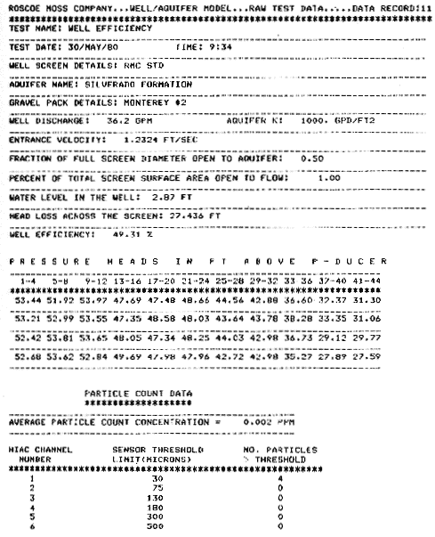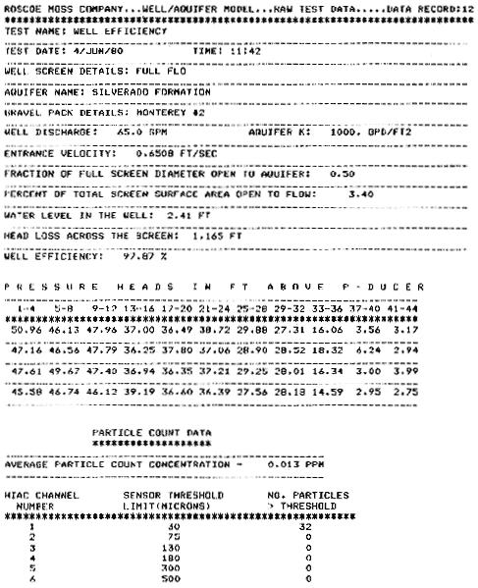

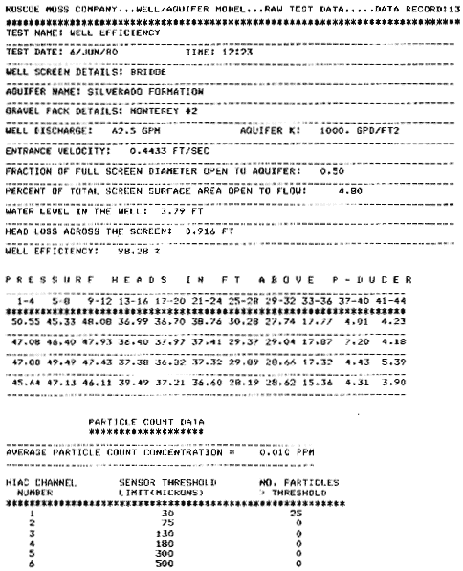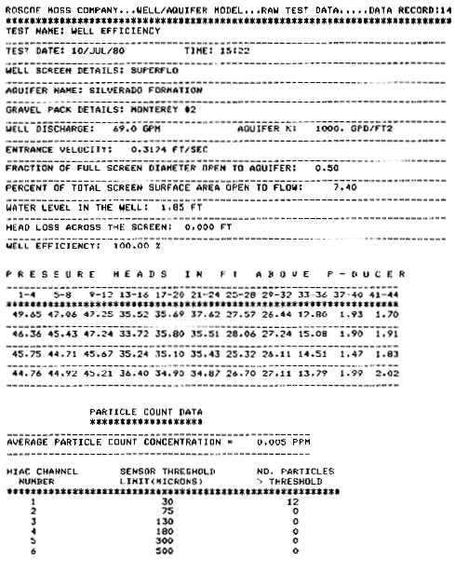

Basic Model Test Data from the First 25 Tests – cont’d

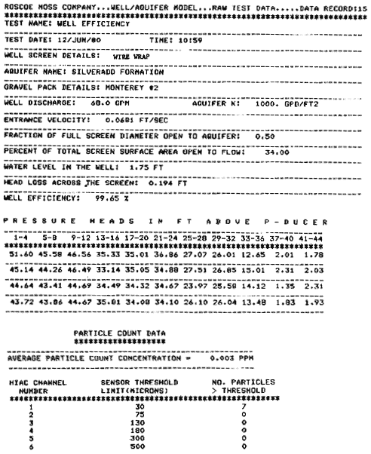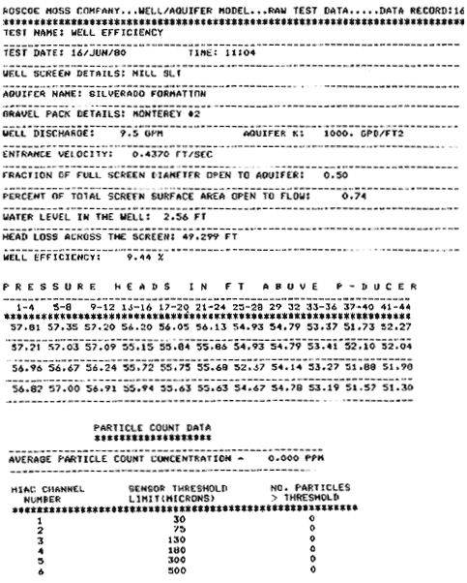

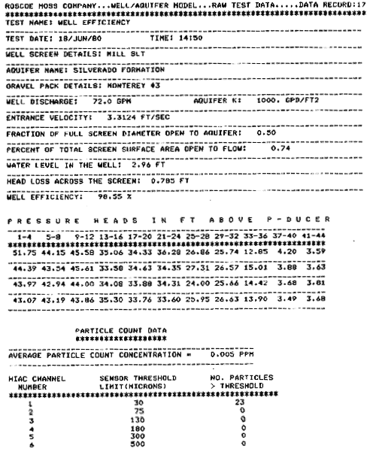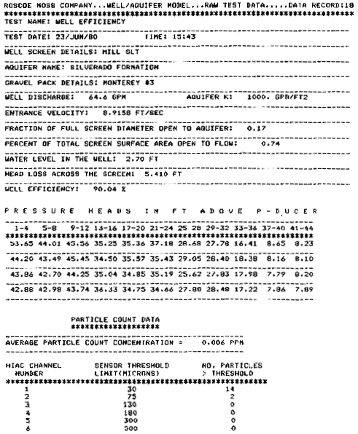

Basic Model Test Data from the First 25 Tests – cont’d

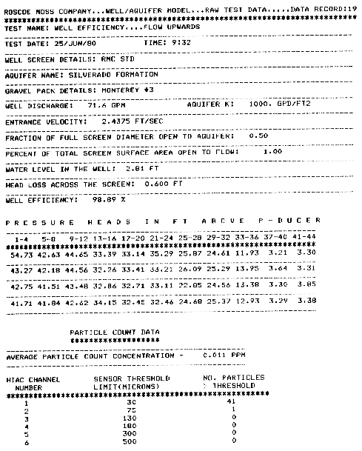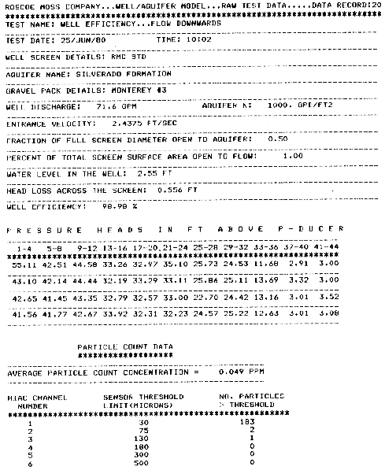

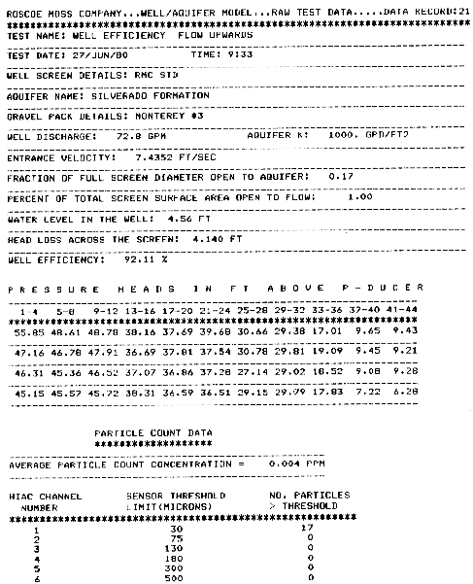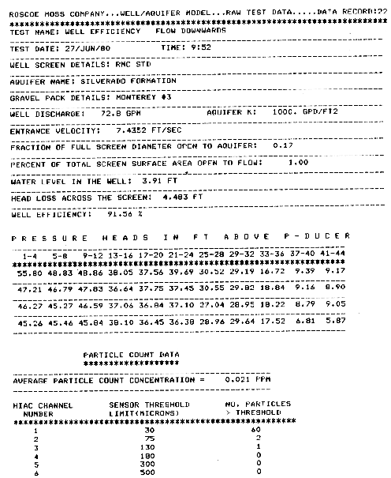

Basic Model Test Data from the First 25 Tests –cont’d

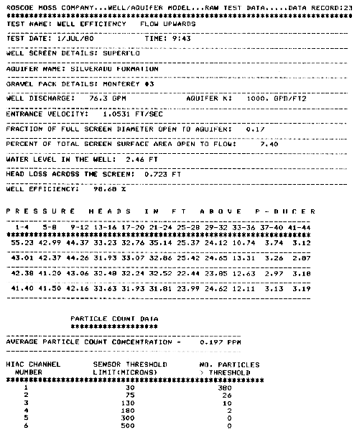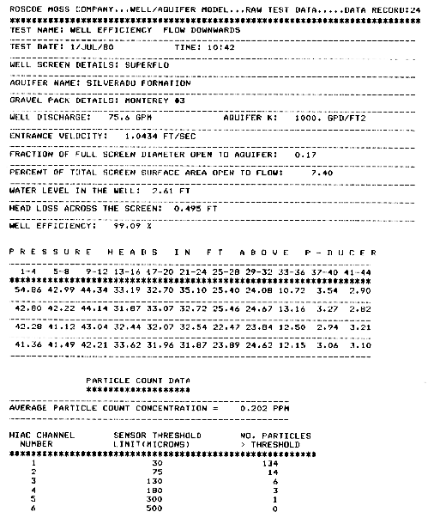

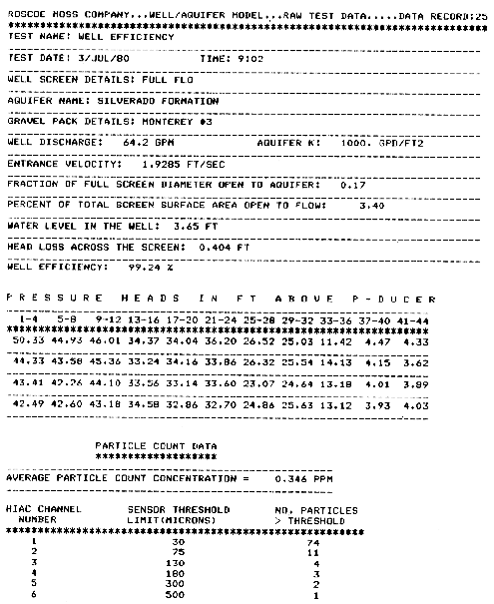

APPENDIX IV

Semi-Logarithmic Plots of Water Level vs. Distance
for Initial 25 Tests (Figs 49-73)
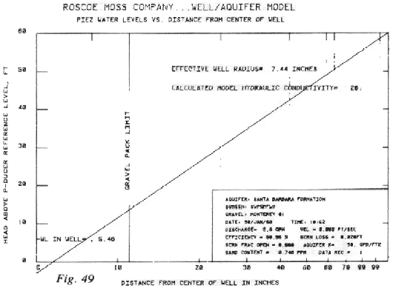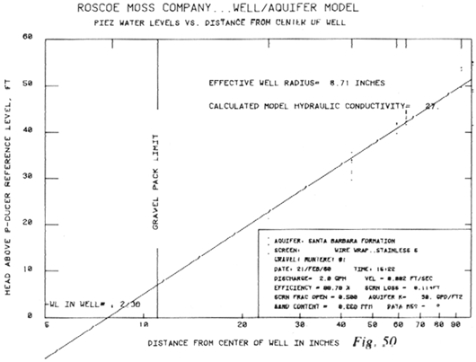

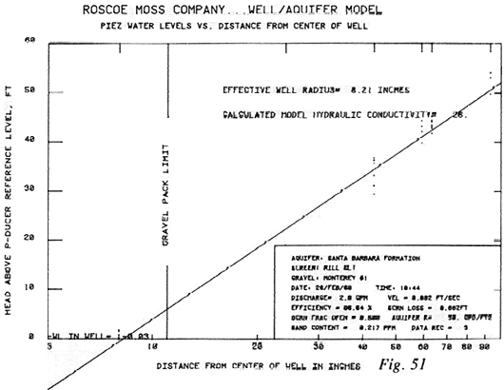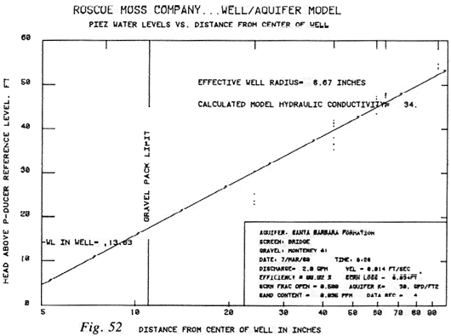

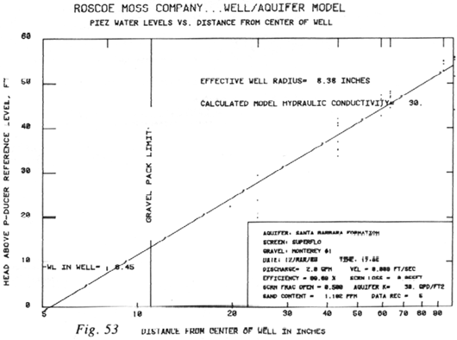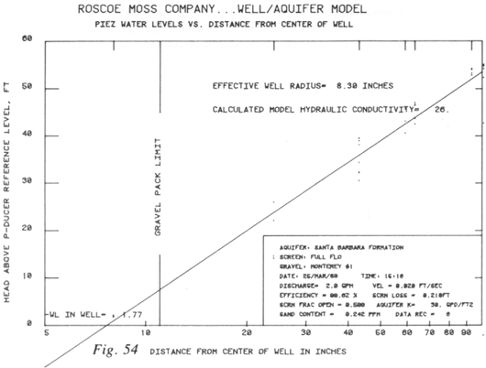

Semi-Logarithmic Plots of Water Level vs. Distance
for Initial 25 Tests (Figs 49-73) – cont’d

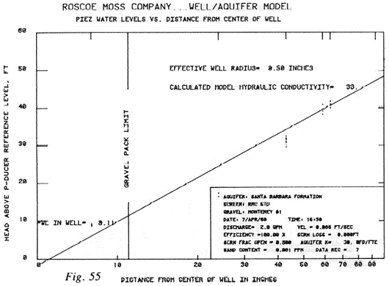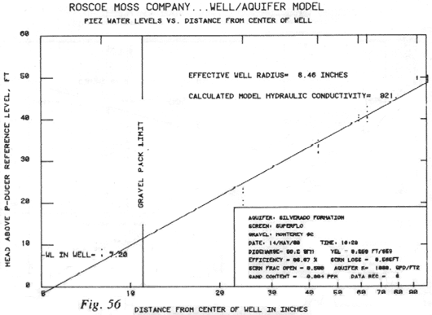

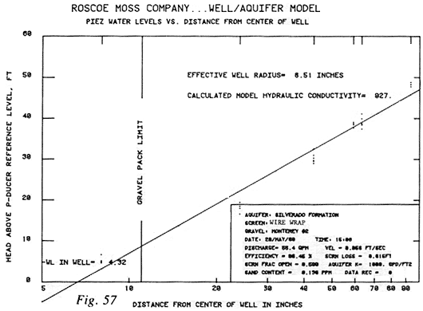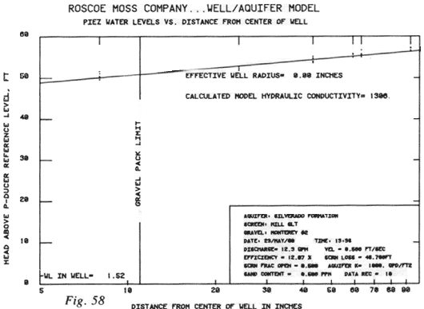

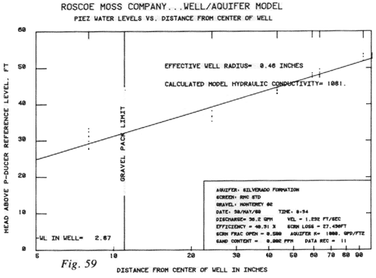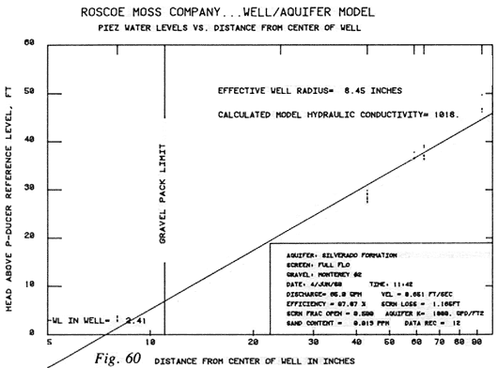

Semi-Logarithmic Plots of Water Level vs. Distance
for Initial 25 Tests (Figs 49-73) – cont’d

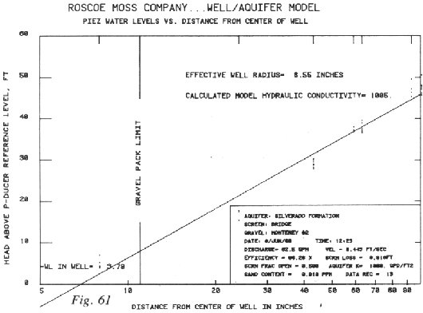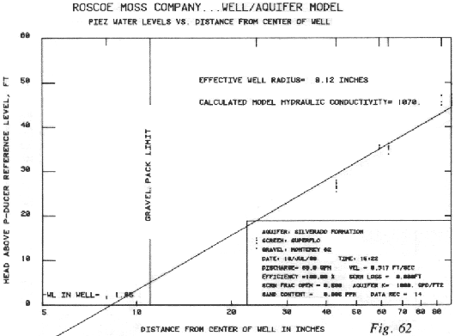

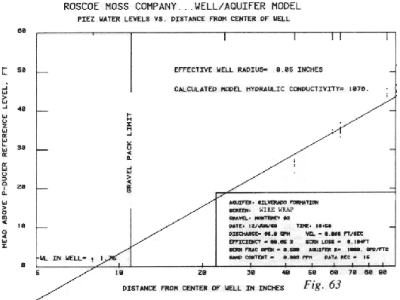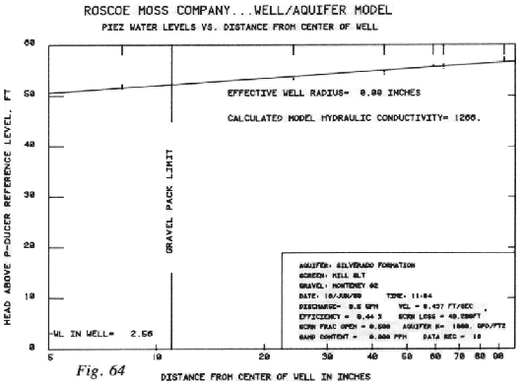

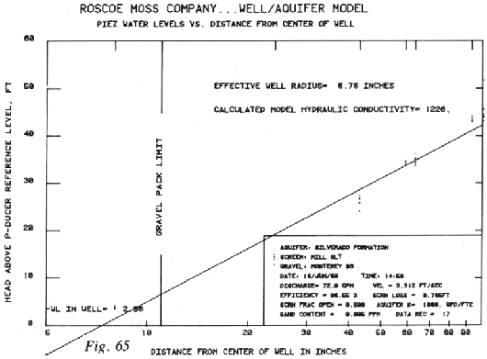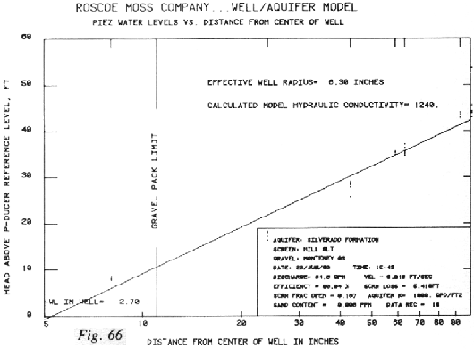

Semi-Logarithmic Plots of Water Level vs. Distance
for Initial 25 Tests (Figs 49-73) – cont’d

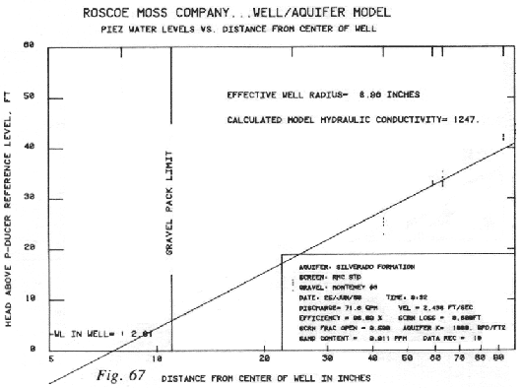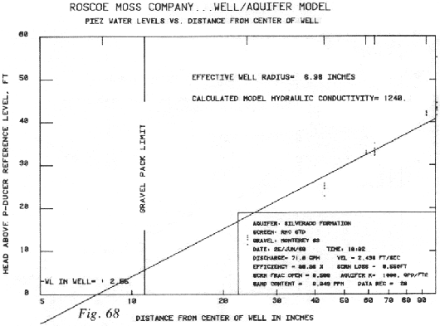

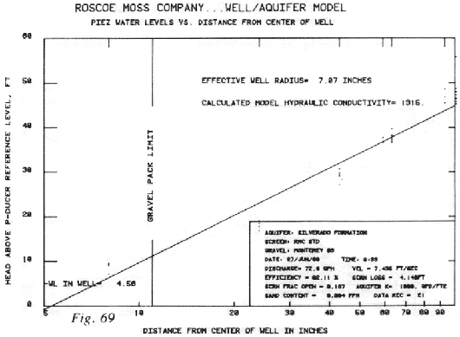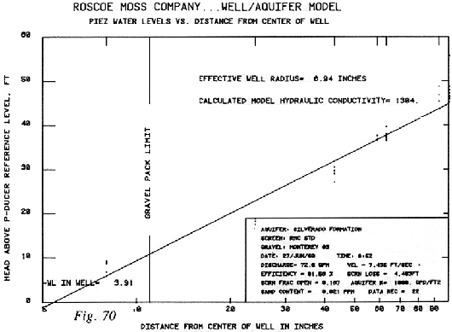

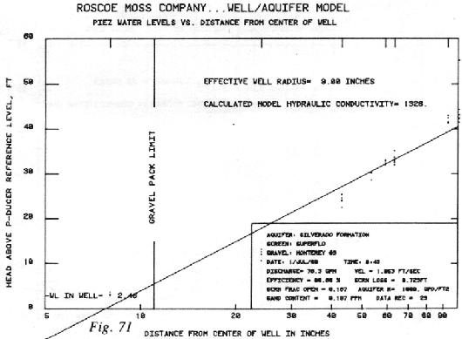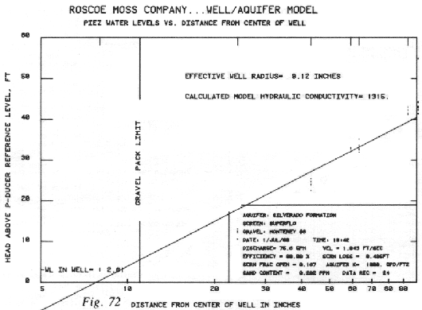

Semi-Logarithmic Plots of Water Level vs. Distance
for Initial 25 Tests (Figs 49-73) – cont’d

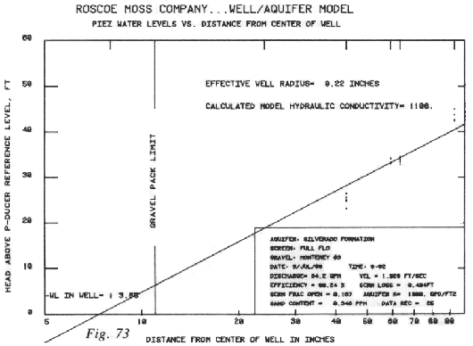

Plot of Percentage Screen Open Area vs. Effective Well Radius for All Tests

APPENDIX V
Computer Source Code Listings (Basic Language)
for the Well/ Aquifer Model Data Logging Program
Contact Roscoe Moss Company to request a copy of the source code.

APPENDIX VI
Computer Source Code Listings (Fortran IV Language)
for Data Analysis and Plotting Programs
Contact Roscoe Moss Company to request a copy of the source code.

